Metanalysis of performance on women caused by (stFemale)

Geiser C. Challco [geiser@alumni.usp.br](mailto:geiser@alumni.usp.br)

Table of Contents

## Initial Variables and Loading Data

env <- "stFemale"  
gender <- "women"  
to_remove <- c('S11')  
sub.groups <- c("country","age","ed.level","intervention",  
 "country:age","country:ed.level","country:intervention",  
 "age:intervention","ed.level:intervention",  
 "country:age:intervention","country:ed.level:intervention")

dat <- read_excel("../data/data-without-outliers.xlsx", sheet = "perform-env.gender-descriptive")  
dat <- dat[!dat$study %in% to_remove, ]  
  
leg <- read_excel("../data/data-without-outliers.xlsx", sheet = "legend")

## New names:  
## • `` -> `...10`

leg <- leg[!leg$study %in% to_remove, ]  
  
idx.e <- which(dat$env == env & dat$gender == gender)  
idx.c <- which(dat$env == "control" & dat$gender == gender)  
  
data <- data.frame(  
 study = dat$study[idx.c],  
 n.e = dat$N[idx.e], mean.e = dat$M[idx.e], sd.e = dat$SD[idx.e],  
 n.c = dat$N[idx.c], mean.c = dat$M[idx.c], sd.c = dat$SD[idx.c]  
)  
for (cgroups in strsplit(sub.groups,":")) {  
 data[[paste0(cgroups, collapse = ":")]] <- sapply(data$study, FUN = function(x) {  
 paste0(sapply(cgroups, FUN = function(namecol) leg[[namecol]][which(x == leg$study)]), collapse = ":")  
 })  
}  
data[["lbl"]] <- sapply(data$study, FUN = function(x) leg$Note[which(x == leg$study)])

## Perform meta-analyses

m.cont <- metacont(  
 n.e = n.e, mean.e = mean.e, sd.e = sd.e, n.c = n.c, mean.c = mean.c, sd.c = sd.c,  
 studlab = lbl, data = data, sm = "SMD", method.smd = "Hedges",  
 fixed = F, random = T, method.tau = "REML", hakn = T, title = paste("Performance for",gender,"in",env)  
)  
summary(m.cont)

## Review: Performance for women in stFemale  
##   
## SMD 95%-CI %W(random)  
## S1 0.0337 [-0.5959; 0.6633] 10.9  
## S2 -0.0214 [-0.5446; 0.5018] 14.8  
## S3 -0.5787 [-1.3128; 0.1555] 8.3  
## S4 0.6745 [-0.1048; 1.4539] 7.4  
## S5 0.2265 [-0.3774; 0.8305] 11.7  
## S6 0.4025 [-0.3214; 1.1264] 8.5  
## S7 0.5444 [-0.0754; 1.1641] 11.2  
## S8: Conducted by BNU -0.1893 [-0.8121; 0.4335] 11.1  
## S9: Albuquerque, et al. (2017) -0.4198 [-1.1460; 0.3064] 8.5  
## S10: Only use prompt msgs 0.1888 [-0.5722; 0.9498] 7.8  
##   
## Number of studies combined: k = 10  
## Number of observations: o = 366  
##   
## SMD 95%-CI t p-value  
## Random effects model 0.0823 [-0.1890; 0.3537] 0.69 0.5098  
##   
## Quantifying heterogeneity:  
## tau^2 = 0.0169 [0.0000; 0.4121]; tau = 0.1299 [0.0000; 0.6420]  
## I^2 = 20.0% [0.0%; 60.5%]; H = 1.12 [1.00; 1.59]  
##   
## Test of heterogeneity:  
## Q d.f. p-value  
## 11.25 9 0.2587  
##   
## Details on meta-analytical method:  
## - Inverse variance method  
## - Restricted maximum-likelihood estimator for tau^2  
## - Q-profile method for confidence interval of tau^2 and tau  
## - Hartung-Knapp adjustment for random effects model  
## - Hedges' g (bias corrected standardised mean difference; using exact formulae)

forest(m.cont, digits=2, digits.sd = 2, test.overall = T, label.e = paste0(gender,':',env))

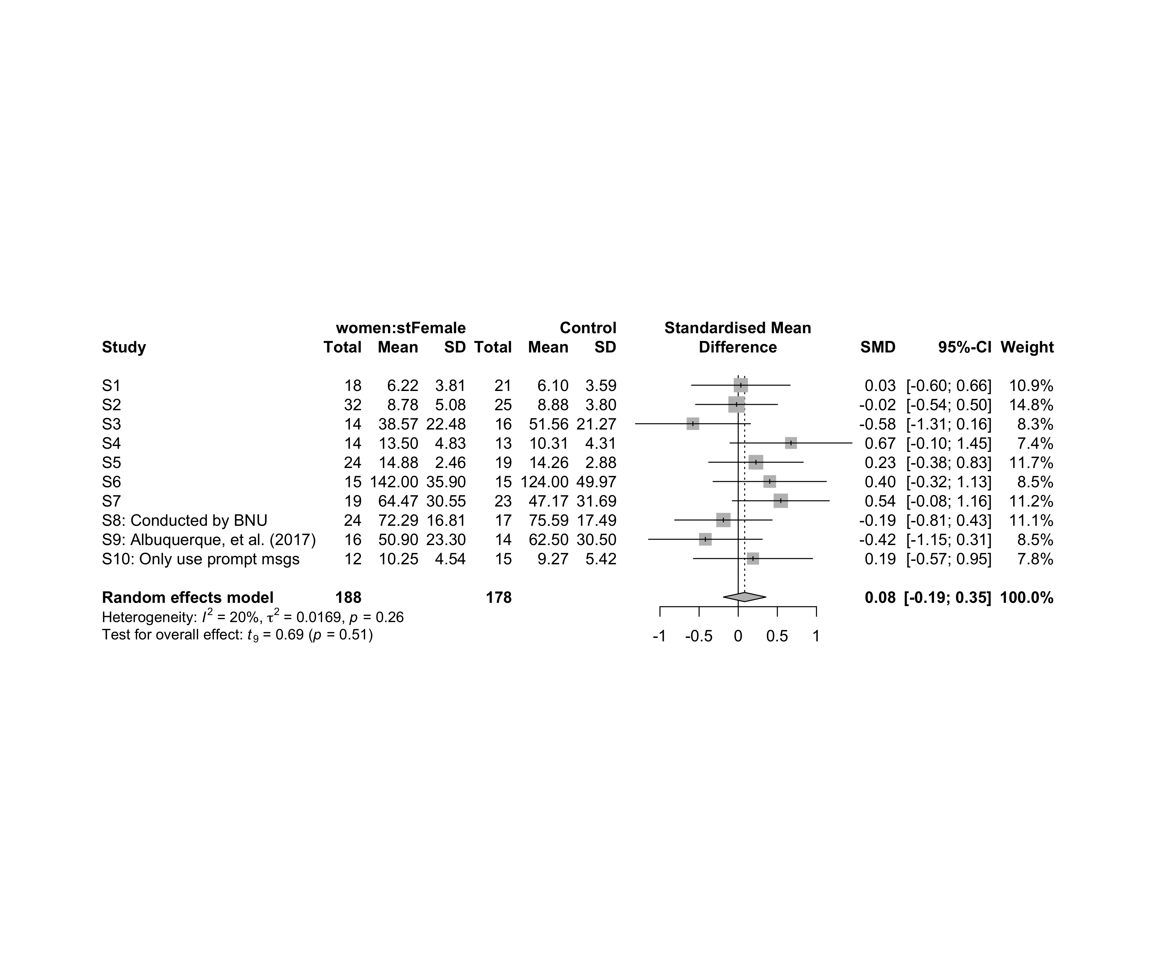

### Subgroup analysis by “country”

m.sg4sub <- update.meta(m.cont, subgroup = country, random = T, fixed = F)  
summary(m.sg4sub)

## Review: Performance for women in stFemale  
##   
## SMD 95%-CI %W(random) country  
## S1 0.0337 [-0.5959; 0.6633] 10.9 Brazil  
## S2 -0.0214 [-0.5446; 0.5018] 14.8 Brazil  
## S3 -0.5787 [-1.3128; 0.1555] 8.3 Brazil  
## S4 0.6745 [-0.1048; 1.4539] 7.4 Brazil  
## S5 0.2265 [-0.3774; 0.8305] 11.7 Brazil  
## S6 0.4025 [-0.3214; 1.1264] 8.5 Brazil  
## S7 0.5444 [-0.0754; 1.1641] 11.2 Brazil  
## S8: Conducted by BNU -0.1893 [-0.8121; 0.4335] 11.1 China  
## S9: Albuquerque, et al. (2017) -0.4198 [-1.1460; 0.3064] 8.5 Brazil  
## S10: Only use prompt msgs 0.1888 [-0.5722; 0.9498] 7.8 Brazil  
##   
## Number of studies combined: k = 10  
## Number of observations: o = 366  
##   
## SMD 95%-CI t p-value  
## Random effects model 0.0823 [-0.1890; 0.3537] 0.69 0.5098  
##   
## Quantifying heterogeneity:  
## tau^2 = 0.0169 [0.0000; 0.4121]; tau = 0.1299 [0.0000; 0.6420]  
## I^2 = 20.0% [0.0%; 60.5%]; H = 1.12 [1.00; 1.59]  
##   
## Test of heterogeneity:  
## Q d.f. p-value  
## 11.25 9 0.2587  
##   
## Results for subgroups (random effects model):  
## k SMD 95%-CI tau^2 tau Q I^2  
## country = Brazil 9 0.1162 [-0.1849; 0.4173] 0.0238 0.1542 10.44 23.3%  
## country = China 1 -0.1893 [-0.8121; 0.4335] -- -- 0.00 --  
##   
## Test for subgroup differences (random effects model):  
## Q d.f. p-value  
## Between groups 0.79 1 0.3738  
##   
## Details on meta-analytical method:  
## - Inverse variance method  
## - Restricted maximum-likelihood estimator for tau^2  
## - Q-profile method for confidence interval of tau^2 and tau  
## - Hartung-Knapp adjustment for random effects model  
## - Hedges' g (bias corrected standardised mean difference; using exact formulae)

forest(m.sg4sub, digits=2, digits.sd = 2, test.overall = T, label.e = paste0(gender,':',env))

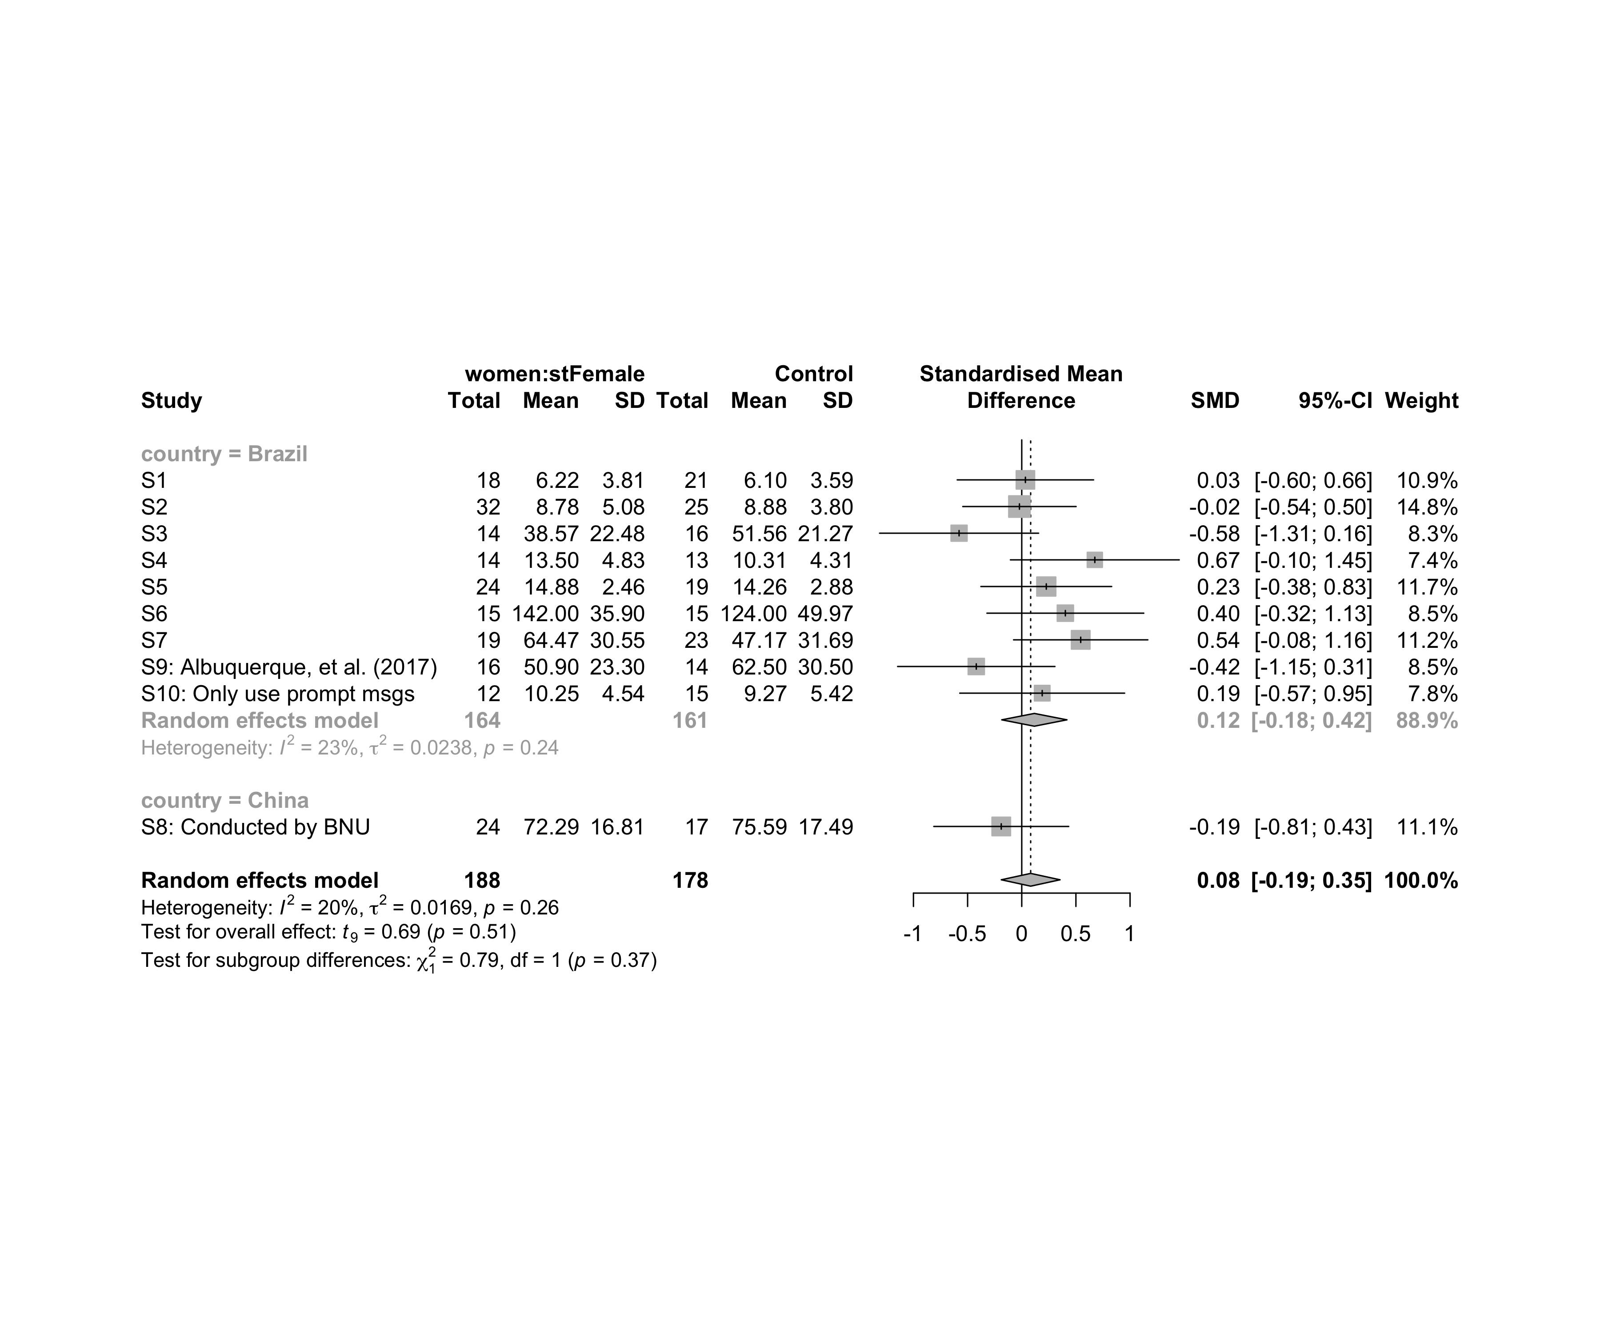

### Subgroup analysis by “age”

m.sg4sub <- update.meta(m.cont, subgroup = age, random = T, fixed = F)  
summary(m.sg4sub)

## Review: Performance for women in stFemale  
##   
## SMD 95%-CI %W(random) age  
## S1 0.0337 [-0.5959; 0.6633] 10.9 adolescent  
## S2 -0.0214 [-0.5446; 0.5018] 14.8 adolescent  
## S3 -0.5787 [-1.3128; 0.1555] 8.3 adolescent  
## S4 0.6745 [-0.1048; 1.4539] 7.4 adult  
## S5 0.2265 [-0.3774; 0.8305] 11.7 adult  
## S6 0.4025 [-0.3214; 1.1264] 8.5 adult  
## S7 0.5444 [-0.0754; 1.1641] 11.2 adult  
## S8: Conducted by BNU -0.1893 [-0.8121; 0.4335] 11.1 unknown  
## S9: Albuquerque, et al. (2017) -0.4198 [-1.1460; 0.3064] 8.5 no-restriction  
## S10: Only use prompt msgs 0.1888 [-0.5722; 0.9498] 7.8 adolescent  
##   
## Number of studies combined: k = 10  
## Number of observations: o = 366  
##   
## SMD 95%-CI t p-value  
## Random effects model 0.0823 [-0.1890; 0.3537] 0.69 0.5098  
##   
## Quantifying heterogeneity:  
## tau^2 = 0.0169 [0.0000; 0.4121]; tau = 0.1299 [0.0000; 0.6420]  
## I^2 = 20.0% [0.0%; 60.5%]; H = 1.12 [1.00; 1.59]  
##   
## Test of heterogeneity:  
## Q d.f. p-value  
## 11.25 9 0.2587  
##   
## Results for subgroups (random effects model):  
## k SMD 95%-CI tau^2 tau Q I^2  
## age = adolescent 4 -0.0759 [-0.5432; 0.3914] 0 0 2.42 0.0%  
## age = adult 4 0.4401 [ 0.1343; 0.7459] 0 0 0.95 0.0%  
## age = unknown 1 -0.1893 [-0.8121; 0.4335] -- -- 0.00 --  
## age = no-restriction 1 -0.4198 [-1.1460; 0.3064] -- -- 0.00 --  
##   
## Test for subgroup differences (random effects model):  
## Q d.f. p-value  
## Between groups 13.94 3 0.0030  
##   
## Details on meta-analytical method:  
## - Inverse variance method  
## - Restricted maximum-likelihood estimator for tau^2  
## - Q-profile method for confidence interval of tau^2 and tau  
## - Hartung-Knapp adjustment for random effects model  
## - Hedges' g (bias corrected standardised mean difference; using exact formulae)

forest(m.sg4sub, digits=2, digits.sd = 2, test.overall = T, label.e = paste0(gender,':',env))

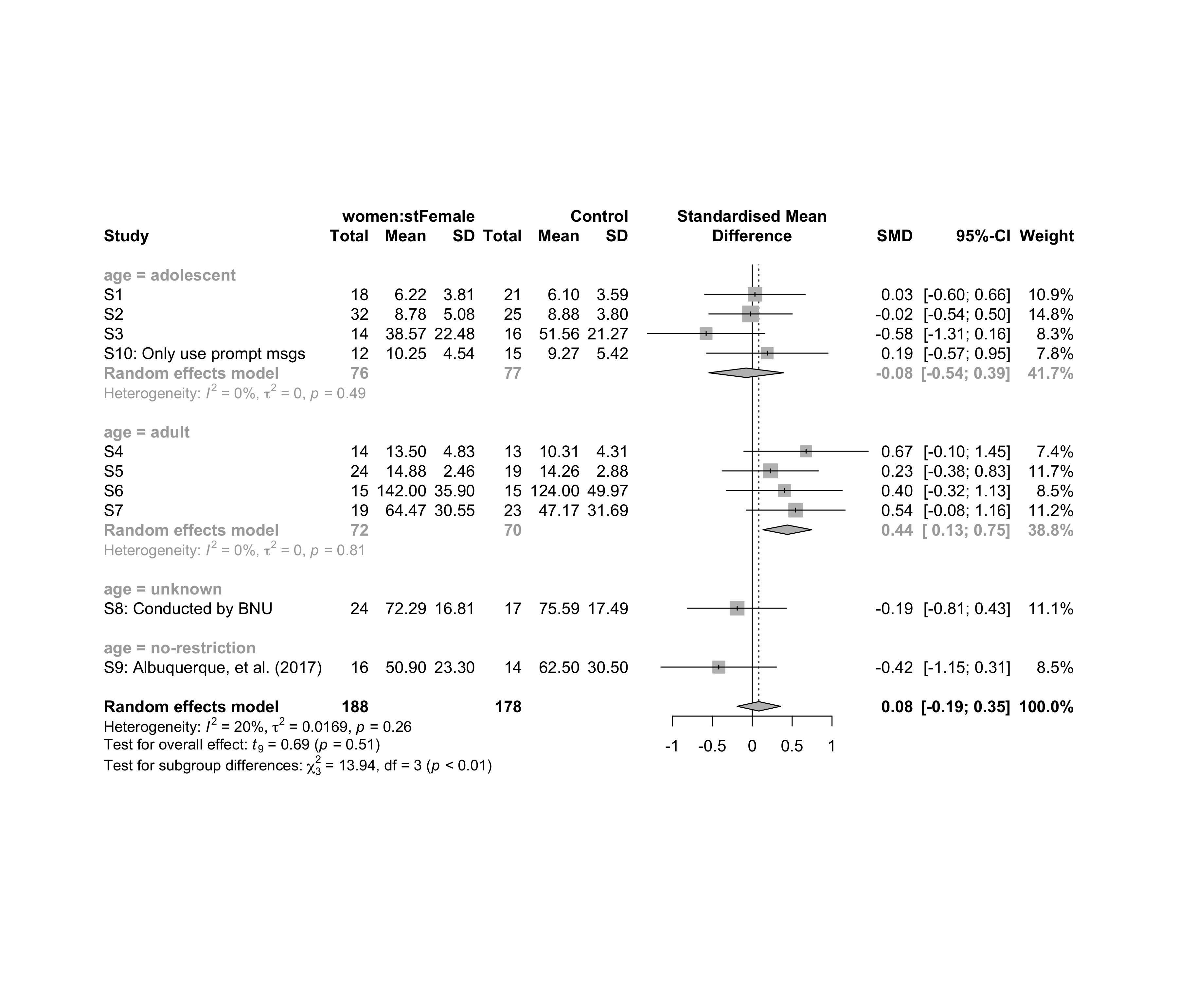

### Subgroup analysis by “ed.level”

m.sg4sub <- update.meta(m.cont, subgroup = ed.level, random = T, fixed = F)  
summary(m.sg4sub)

## Review: Performance for women in stFemale  
##   
## SMD 95%-CI %W(random) ed.level  
## S1 0.0337 [-0.5959; 0.6633] 10.9 upper-secundary  
## S2 -0.0214 [-0.5446; 0.5018] 14.8 upper-secundary  
## S3 -0.5787 [-1.3128; 0.1555] 8.3 upper-secundary  
## S4 0.6745 [-0.1048; 1.4539] 7.4 higher-education  
## S5 0.2265 [-0.3774; 0.8305] 11.7 higher-education  
## S6 0.4025 [-0.3214; 1.1264] 8.5 higher-education  
## S7 0.5444 [-0.0754; 1.1641] 11.2 unknown  
## S8: Conducted by BNU -0.1893 [-0.8121; 0.4335] 11.1 unknown  
## S9: Albuquerque, et al. (2017) -0.4198 [-1.1460; 0.3064] 8.5 unknown  
## S10: Only use prompt msgs 0.1888 [-0.5722; 0.9498] 7.8 upper-secundary  
##   
## Number of studies combined: k = 10  
## Number of observations: o = 366  
##   
## SMD 95%-CI t p-value  
## Random effects model 0.0823 [-0.1890; 0.3537] 0.69 0.5098  
##   
## Quantifying heterogeneity:  
## tau^2 = 0.0169 [0.0000; 0.4121]; tau = 0.1299 [0.0000; 0.6420]  
## I^2 = 20.0% [0.0%; 60.5%]; H = 1.12 [1.00; 1.59]  
##   
## Test of heterogeneity:  
## Q d.f. p-value  
## 11.25 9 0.2587  
##   
## Results for subgroups (random effects model):  
## k SMD 95%-CI tau^2 tau Q I^2  
## ed.level = upper-secundary 4 -0.0759 [-0.5432; 0.3914] 0 0 2.42 0.0%  
## ed.level = higher-education 3 0.3970 [-0.1540; 0.9481] 0 0 0.79 0.0%  
## ed.level = unknown 3 -0.0029 [-1.2549; 1.2491] 0.1440 0.3795 4.59 56.5%  
##   
## Test for subgroup differences (random effects model):  
## Q d.f. p-value  
## Between groups 6.30 2 0.0429  
##   
## Details on meta-analytical method:  
## - Inverse variance method  
## - Restricted maximum-likelihood estimator for tau^2  
## - Q-profile method for confidence interval of tau^2 and tau  
## - Hartung-Knapp adjustment for random effects model  
## - Hedges' g (bias corrected standardised mean difference; using exact formulae)

forest(m.sg4sub, digits=2, digits.sd = 2, test.overall = T, label.e = paste0(gender,':',env))

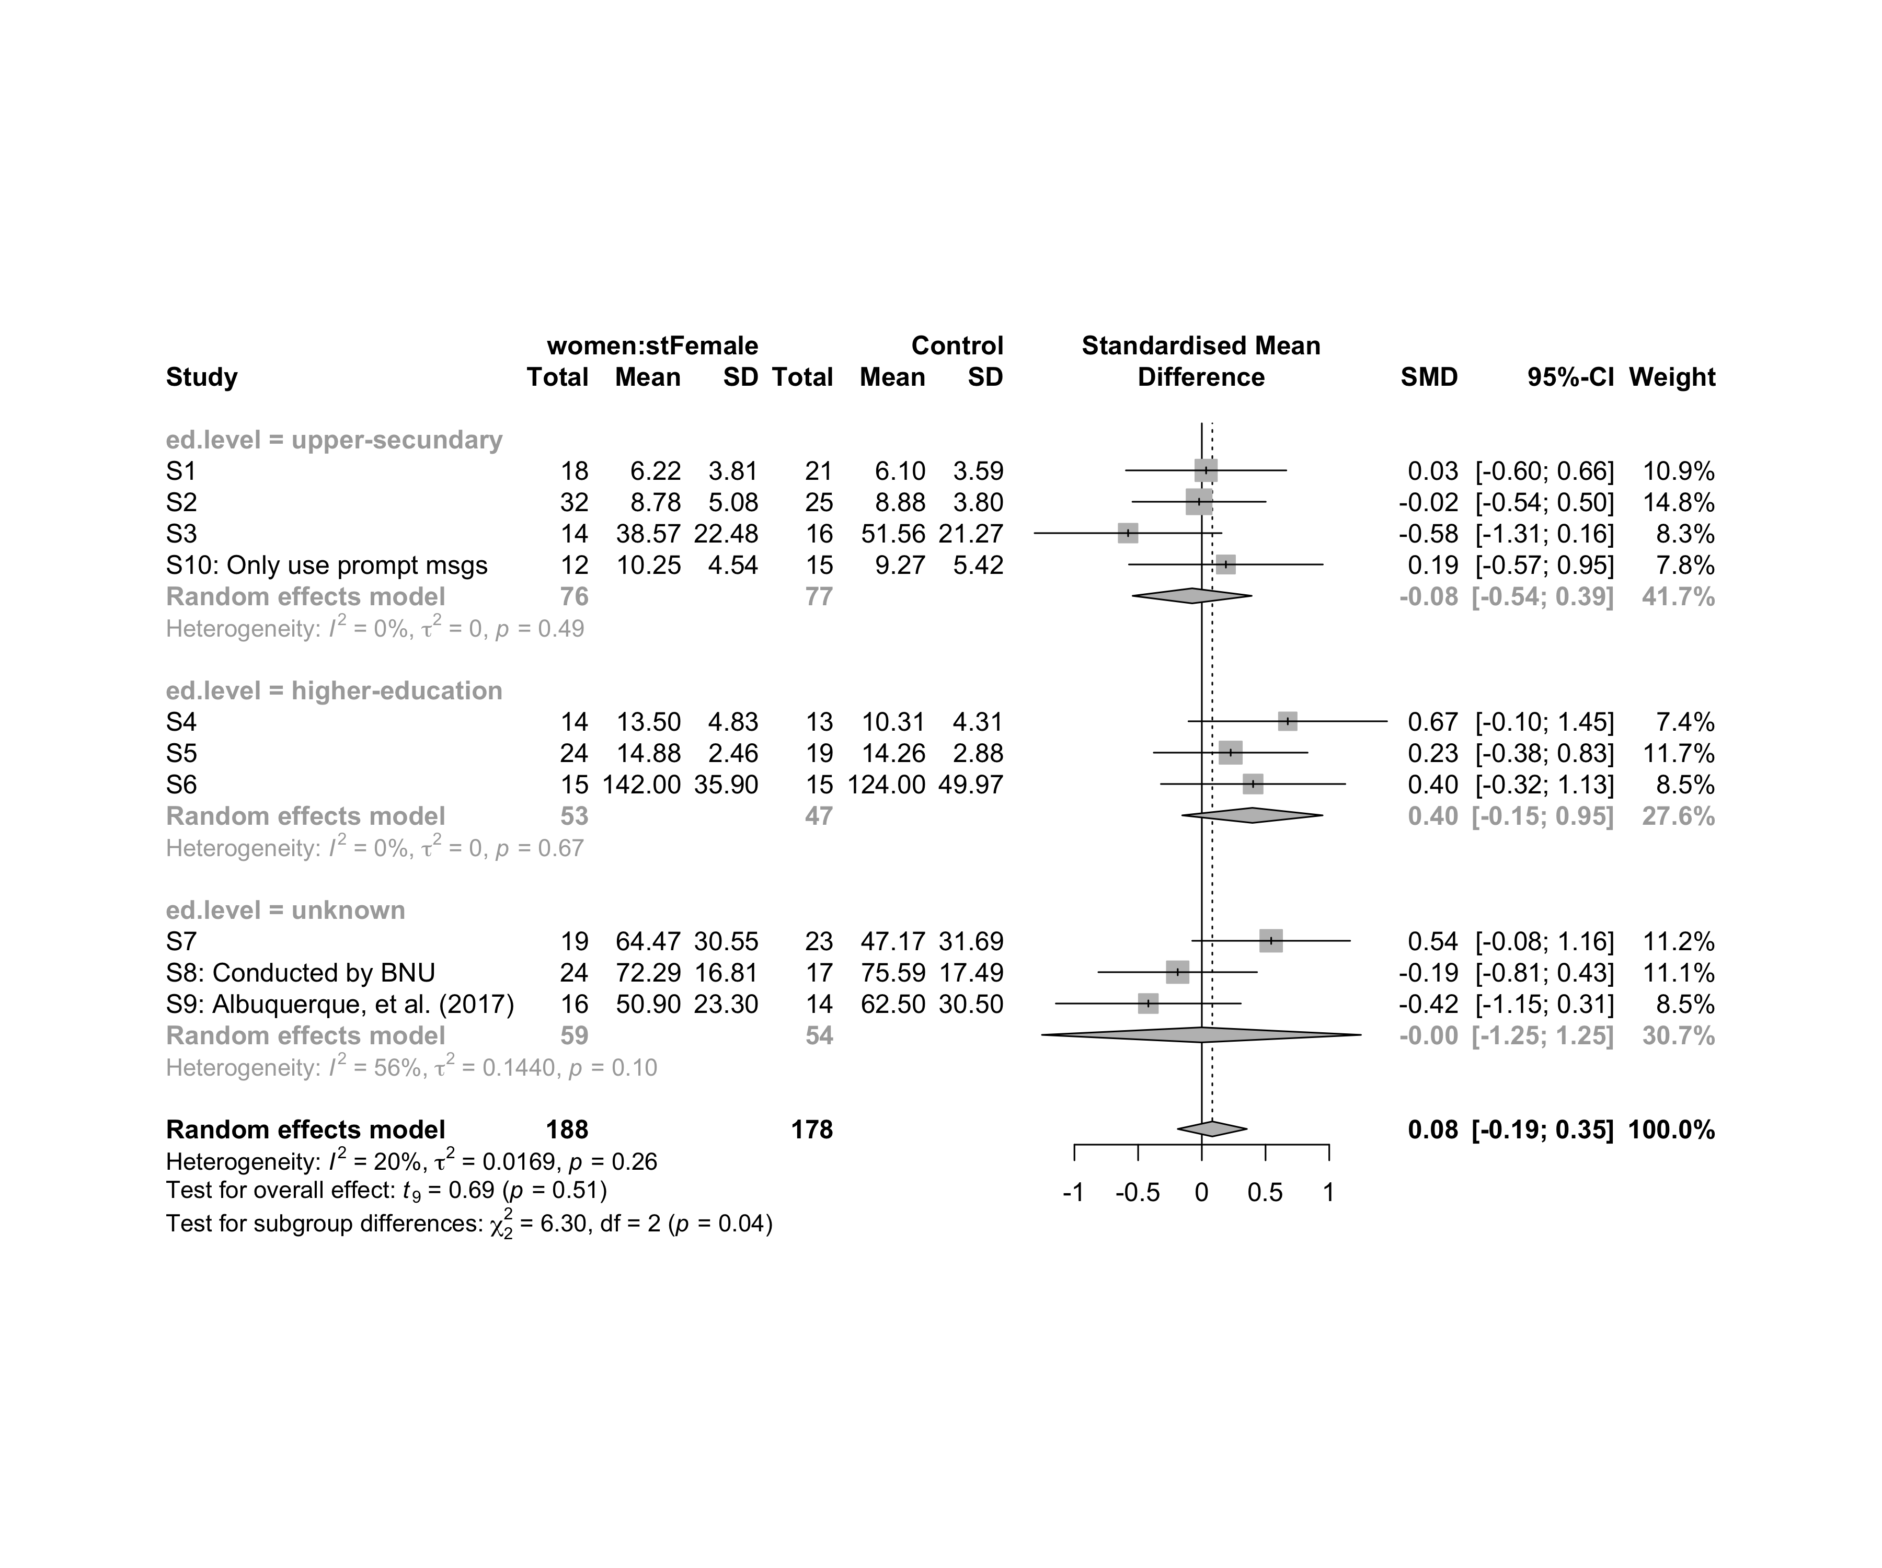

### Subgroup analysis by “intervention”

m.sg4sub <- update.meta(m.cont, subgroup = intervention, random = T, fixed = F)  
summary(m.sg4sub)

## Review: Performance for women in stFemale  
##   
## SMD 95%-CI %W(random)  
## S1 0.0337 [-0.5959; 0.6633] 10.9  
## S2 -0.0214 [-0.5446; 0.5018] 14.8  
## S3 -0.5787 [-1.3128; 0.1555] 8.3  
## S4 0.6745 [-0.1048; 1.4539] 7.4  
## S5 0.2265 [-0.3774; 0.8305] 11.7  
## S6 0.4025 [-0.3214; 1.1264] 8.5  
## S7 0.5444 [-0.0754; 1.1641] 11.2  
## S8: Conducted by BNU -0.1893 [-0.8121; 0.4335] 11.1  
## S9: Albuquerque, et al. (2017) -0.4198 [-1.1460; 0.3064] 8.5  
## S10: Only use prompt msgs 0.1888 [-0.5722; 0.9498] 7.8  
## intervention  
## S1 Gender-stereotype color, ranking, badges, and avatar  
## S2 Gender-stereotype color, ranking, badges, and avatar  
## S3 Gender-stereotype color, ranking, badges, and avatar  
## S4 Gender-stereotype color, ranking, badges, and avatar  
## S5 Gender-stereotype color, ranking, badges, and avatar  
## S6 Gender-stereotype color, ranking, badges, and avatar  
## S7 Gender-stereotype color, ranking, badges, and avatar  
## S8: Conducted by BNU Gender-stereotype color, ranking, badges, and avatar  
## S9: Albuquerque, et al. (2017) Gender-stereotype color, ranking, badges, and avatar  
## S10: Only use prompt msgs Gender-stereotyped motivational message prompts  
##   
## Number of studies combined: k = 10  
## Number of observations: o = 366  
##   
## SMD 95%-CI t p-value  
## Random effects model 0.0823 [-0.1890; 0.3537] 0.69 0.5098  
##   
## Quantifying heterogeneity:  
## tau^2 = 0.0169 [0.0000; 0.4121]; tau = 0.1299 [0.0000; 0.6420]  
## I^2 = 20.0% [0.0%; 60.5%]; H = 1.12 [1.00; 1.59]  
##   
## Test of heterogeneity:  
## Q d.f. p-value  
## 11.25 9 0.2587  
##   
## Results for subgroups (random effects model):  
## k SMD 95%-CI tau^2 tau Q I^2  
## intervention = Gender-stereotype color, rankin ... 9 0.0735 [-0.2336; 0.3805] 0.0318 0.1782 11.17 28.4%  
## intervention = Gender-stereotyped motivational ... 1 0.1888 [-0.5722; 0.9498] -- -- 0.00 --  
##   
## Test for subgroup differences (random effects model):  
## Q d.f. p-value  
## Between groups 0.08 1 0.7788  
##   
## Details on meta-analytical method:  
## - Inverse variance method  
## - Restricted maximum-likelihood estimator for tau^2  
## - Q-profile method for confidence interval of tau^2 and tau  
## - Hartung-Knapp adjustment for random effects model  
## - Hedges' g (bias corrected standardised mean difference; using exact formulae)

forest(m.sg4sub, digits=2, digits.sd = 2, test.overall = T, label.e = paste0(gender,':',env))

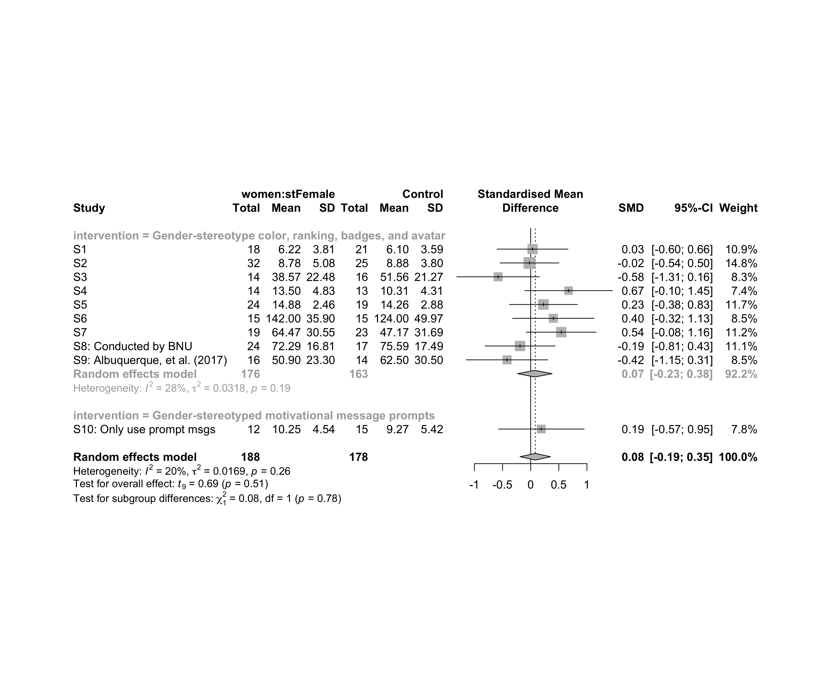

### Subgroup analysis by “country:age”

m.sg4sub <- update.meta(m.cont, subgroup = `country:age`, random = T, fixed = F)  
summary(m.sg4sub)

## Review: Performance for women in stFemale  
##   
## SMD 95%-CI %W(random) country:age  
## S1 0.0337 [-0.5959; 0.6633] 10.9 Brazil:adolescent  
## S2 -0.0214 [-0.5446; 0.5018] 14.8 Brazil:adolescent  
## S3 -0.5787 [-1.3128; 0.1555] 8.3 Brazil:adolescent  
## S4 0.6745 [-0.1048; 1.4539] 7.4 Brazil:adult  
## S5 0.2265 [-0.3774; 0.8305] 11.7 Brazil:adult  
## S6 0.4025 [-0.3214; 1.1264] 8.5 Brazil:adult  
## S7 0.5444 [-0.0754; 1.1641] 11.2 Brazil:adult  
## S8: Conducted by BNU -0.1893 [-0.8121; 0.4335] 11.1 China:unknown  
## S9: Albuquerque, et al. (2017) -0.4198 [-1.1460; 0.3064] 8.5 Brazil:no-restriction  
## S10: Only use prompt msgs 0.1888 [-0.5722; 0.9498] 7.8 Brazil:adolescent  
##   
## Number of studies combined: k = 10  
## Number of observations: o = 366  
##   
## SMD 95%-CI t p-value  
## Random effects model 0.0823 [-0.1890; 0.3537] 0.69 0.5098  
##   
## Quantifying heterogeneity:  
## tau^2 = 0.0169 [0.0000; 0.4121]; tau = 0.1299 [0.0000; 0.6420]  
## I^2 = 20.0% [0.0%; 60.5%]; H = 1.12 [1.00; 1.59]  
##   
## Test of heterogeneity:  
## Q d.f. p-value  
## 11.25 9 0.2587  
##   
## Results for subgroups (random effects model):  
## k SMD 95%-CI tau^2 tau Q I^2  
## country:age = Brazil:adolescent 4 -0.0759 [-0.5432; 0.3914] 0 0 2.42 0.0%  
## country:age = Brazil:adult 4 0.4401 [ 0.1343; 0.7459] 0 0 0.95 0.0%  
## country:age = China:unknown 1 -0.1893 [-0.8121; 0.4335] -- -- 0.00 --  
## country:age = Brazil:no-restriction 1 -0.4198 [-1.1460; 0.3064] -- -- 0.00 --  
##   
## Test for subgroup differences (random effects model):  
## Q d.f. p-value  
## Between groups 13.94 3 0.0030  
##   
## Details on meta-analytical method:  
## - Inverse variance method  
## - Restricted maximum-likelihood estimator for tau^2  
## - Q-profile method for confidence interval of tau^2 and tau  
## - Hartung-Knapp adjustment for random effects model  
## - Hedges' g (bias corrected standardised mean difference; using exact formulae)

forest(m.sg4sub, digits=2, digits.sd = 2, test.overall = T, label.e = paste0(gender,':',env))

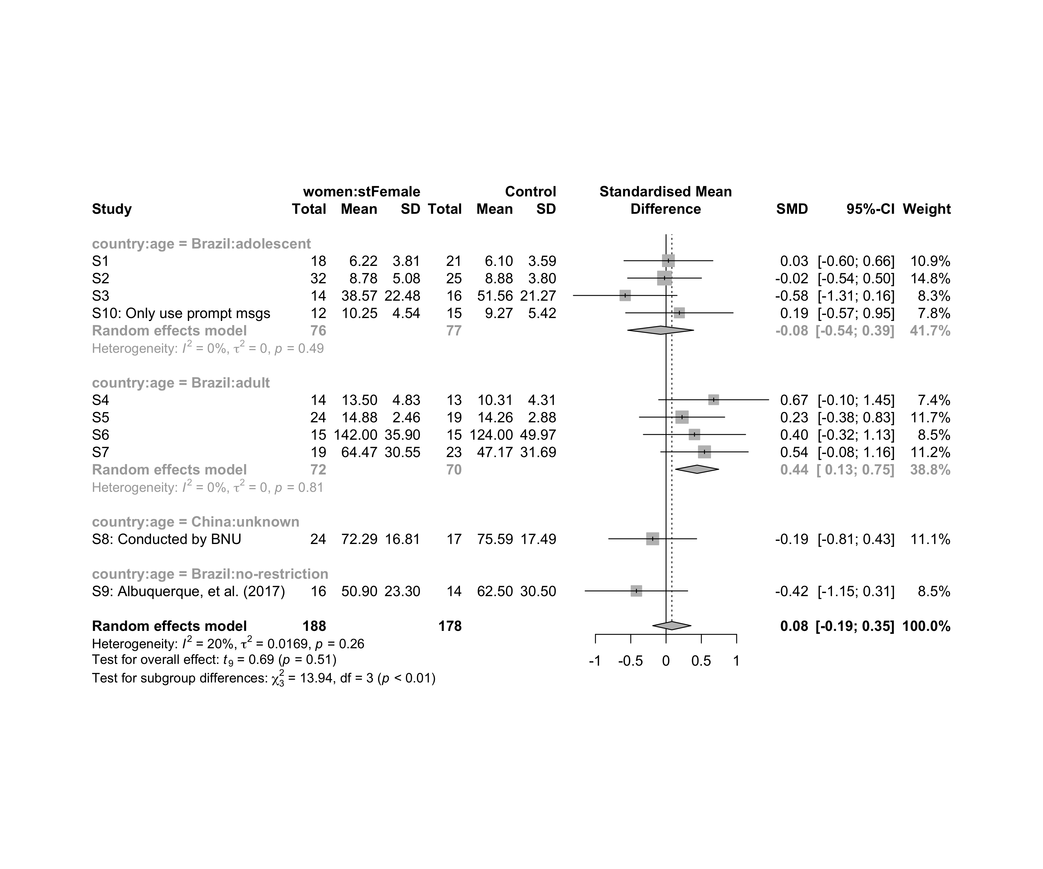

### Subgroup analysis by “country:ed.level”

m.sg4sub <- update.meta(m.cont, subgroup = `country:ed.level`, random = T, fixed = F)  
summary(m.sg4sub)

## Review: Performance for women in stFemale  
##   
## SMD 95%-CI %W(random) country:ed.level  
## S1 0.0337 [-0.5959; 0.6633] 10.9 Brazil:upper-secundary  
## S2 -0.0214 [-0.5446; 0.5018] 14.8 Brazil:upper-secundary  
## S3 -0.5787 [-1.3128; 0.1555] 8.3 Brazil:upper-secundary  
## S4 0.6745 [-0.1048; 1.4539] 7.4 Brazil:higher-education  
## S5 0.2265 [-0.3774; 0.8305] 11.7 Brazil:higher-education  
## S6 0.4025 [-0.3214; 1.1264] 8.5 Brazil:higher-education  
## S7 0.5444 [-0.0754; 1.1641] 11.2 Brazil:unknown  
## S8: Conducted by BNU -0.1893 [-0.8121; 0.4335] 11.1 China:unknown  
## S9: Albuquerque, et al. (2017) -0.4198 [-1.1460; 0.3064] 8.5 Brazil:unknown  
## S10: Only use prompt msgs 0.1888 [-0.5722; 0.9498] 7.8 Brazil:upper-secundary  
##   
## Number of studies combined: k = 10  
## Number of observations: o = 366  
##   
## SMD 95%-CI t p-value  
## Random effects model 0.0823 [-0.1890; 0.3537] 0.69 0.5098  
##   
## Quantifying heterogeneity:  
## tau^2 = 0.0169 [0.0000; 0.4121]; tau = 0.1299 [0.0000; 0.6420]  
## I^2 = 20.0% [0.0%; 60.5%]; H = 1.12 [1.00; 1.59]  
##   
## Test of heterogeneity:  
## Q d.f. p-value  
## 11.25 9 0.2587  
##   
## Results for subgroups (random effects model):  
## k SMD 95%-CI tau^2 tau Q I^2  
## country:ed.level = Brazil:upper-secundary 4 -0.0759 [-0.5432; 0.3914] 0 0 2.42 0.0%  
## country:ed.level = Brazil:higher-education 3 0.3970 [-0.1540; 0.9481] 0 0 0.79 0.0%  
## country:ed.level = Brazil:unknown 2 0.0816 [-6.0390; 6.2023] 0.3462 0.5884 3.92 74.5%  
## country:ed.level = China:unknown 1 -0.1893 [-0.8121; 0.4335] -- -- 0.00 --  
##   
## Test for subgroup differences (random effects model):  
## Q d.f. p-value  
## Between groups 7.24 3 0.0646  
##   
## Details on meta-analytical method:  
## - Inverse variance method  
## - Restricted maximum-likelihood estimator for tau^2  
## - Q-profile method for confidence interval of tau^2 and tau  
## - Hartung-Knapp adjustment for random effects model  
## - Hedges' g (bias corrected standardised mean difference; using exact formulae)

forest(m.sg4sub, digits=2, digits.sd = 2, test.overall = T, label.e = paste0(gender,':',env))

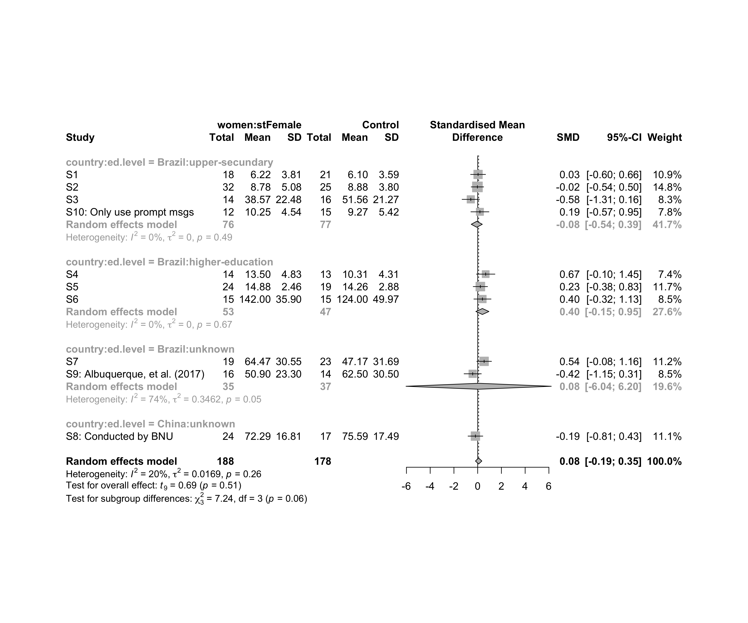

### Subgroup analysis by “country:intervention”

m.sg4sub <- update.meta(m.cont, subgroup = `country:intervention`, random = T, fixed = F)  
summary(m.sg4sub)

## Review: Performance for women in stFemale  
##   
## SMD 95%-CI %W(random)  
## S1 0.0337 [-0.5959; 0.6633] 10.9  
## S2 -0.0214 [-0.5446; 0.5018] 14.8  
## S3 -0.5787 [-1.3128; 0.1555] 8.3  
## S4 0.6745 [-0.1048; 1.4539] 7.4  
## S5 0.2265 [-0.3774; 0.8305] 11.7  
## S6 0.4025 [-0.3214; 1.1264] 8.5  
## S7 0.5444 [-0.0754; 1.1641] 11.2  
## S8: Conducted by BNU -0.1893 [-0.8121; 0.4335] 11.1  
## S9: Albuquerque, et al. (2017) -0.4198 [-1.1460; 0.3064] 8.5  
## S10: Only use prompt msgs 0.1888 [-0.5722; 0.9498] 7.8  
## country:intervention  
## S1 Brazil:Gender-stereotype color, ranking, badges, and avatar  
## S2 Brazil:Gender-stereotype color, ranking, badges, and avatar  
## S3 Brazil:Gender-stereotype color, ranking, badges, and avatar  
## S4 Brazil:Gender-stereotype color, ranking, badges, and avatar  
## S5 Brazil:Gender-stereotype color, ranking, badges, and avatar  
## S6 Brazil:Gender-stereotype color, ranking, badges, and avatar  
## S7 Brazil:Gender-stereotype color, ranking, badges, and avatar  
## S8: Conducted by BNU China:Gender-stereotype color, ranking, badges, and avatar  
## S9: Albuquerque, et al. (2017) Brazil:Gender-stereotype color, ranking, badges, and avatar  
## S10: Only use prompt msgs Brazil:Gender-stereotyped motivational message prompts  
##   
## Number of studies combined: k = 10  
## Number of observations: o = 366  
##   
## SMD 95%-CI t p-value  
## Random effects model 0.0823 [-0.1890; 0.3537] 0.69 0.5098  
##   
## Quantifying heterogeneity:  
## tau^2 = 0.0169 [0.0000; 0.4121]; tau = 0.1299 [0.0000; 0.6420]  
## I^2 = 20.0% [0.0%; 60.5%]; H = 1.12 [1.00; 1.59]  
##   
## Test of heterogeneity:  
## Q d.f. p-value  
## 11.25 9 0.2587  
##   
## Results for subgroups (random effects model):  
## k SMD 95%-CI tau^2 tau  
## country:intervention = Brazil:Gender-stereotype color, ... 8 0.1091 [-0.2395; 0.4577] 0.0434 0.2082  
## country:intervention = China:Gender-stereotype color, ... 1 -0.1893 [-0.8121; 0.4335] -- --  
## country:intervention = Brazil:Gender-stereotyped motiv ... 1 0.1888 [-0.5722; 0.9498] -- --  
## Q I^2  
## country:intervention = Brazil:Gender-stereotype color, ... 10.40 32.7%  
## country:intervention = China:Gender-stereotype color, ... 0.00 --  
## country:intervention = Brazil:Gender-stereotyped motiv ... 0.00 --  
##   
## Test for subgroup differences (random effects model):  
## Q d.f. p-value  
## Between groups 0.83 2 0.6604  
##   
## Details on meta-analytical method:  
## - Inverse variance method  
## - Restricted maximum-likelihood estimator for tau^2  
## - Q-profile method for confidence interval of tau^2 and tau  
## - Hartung-Knapp adjustment for random effects model  
## - Hedges' g (bias corrected standardised mean difference; using exact formulae)

forest(m.sg4sub, digits=2, digits.sd = 2, test.overall = T, label.e = paste0(gender,':',env))

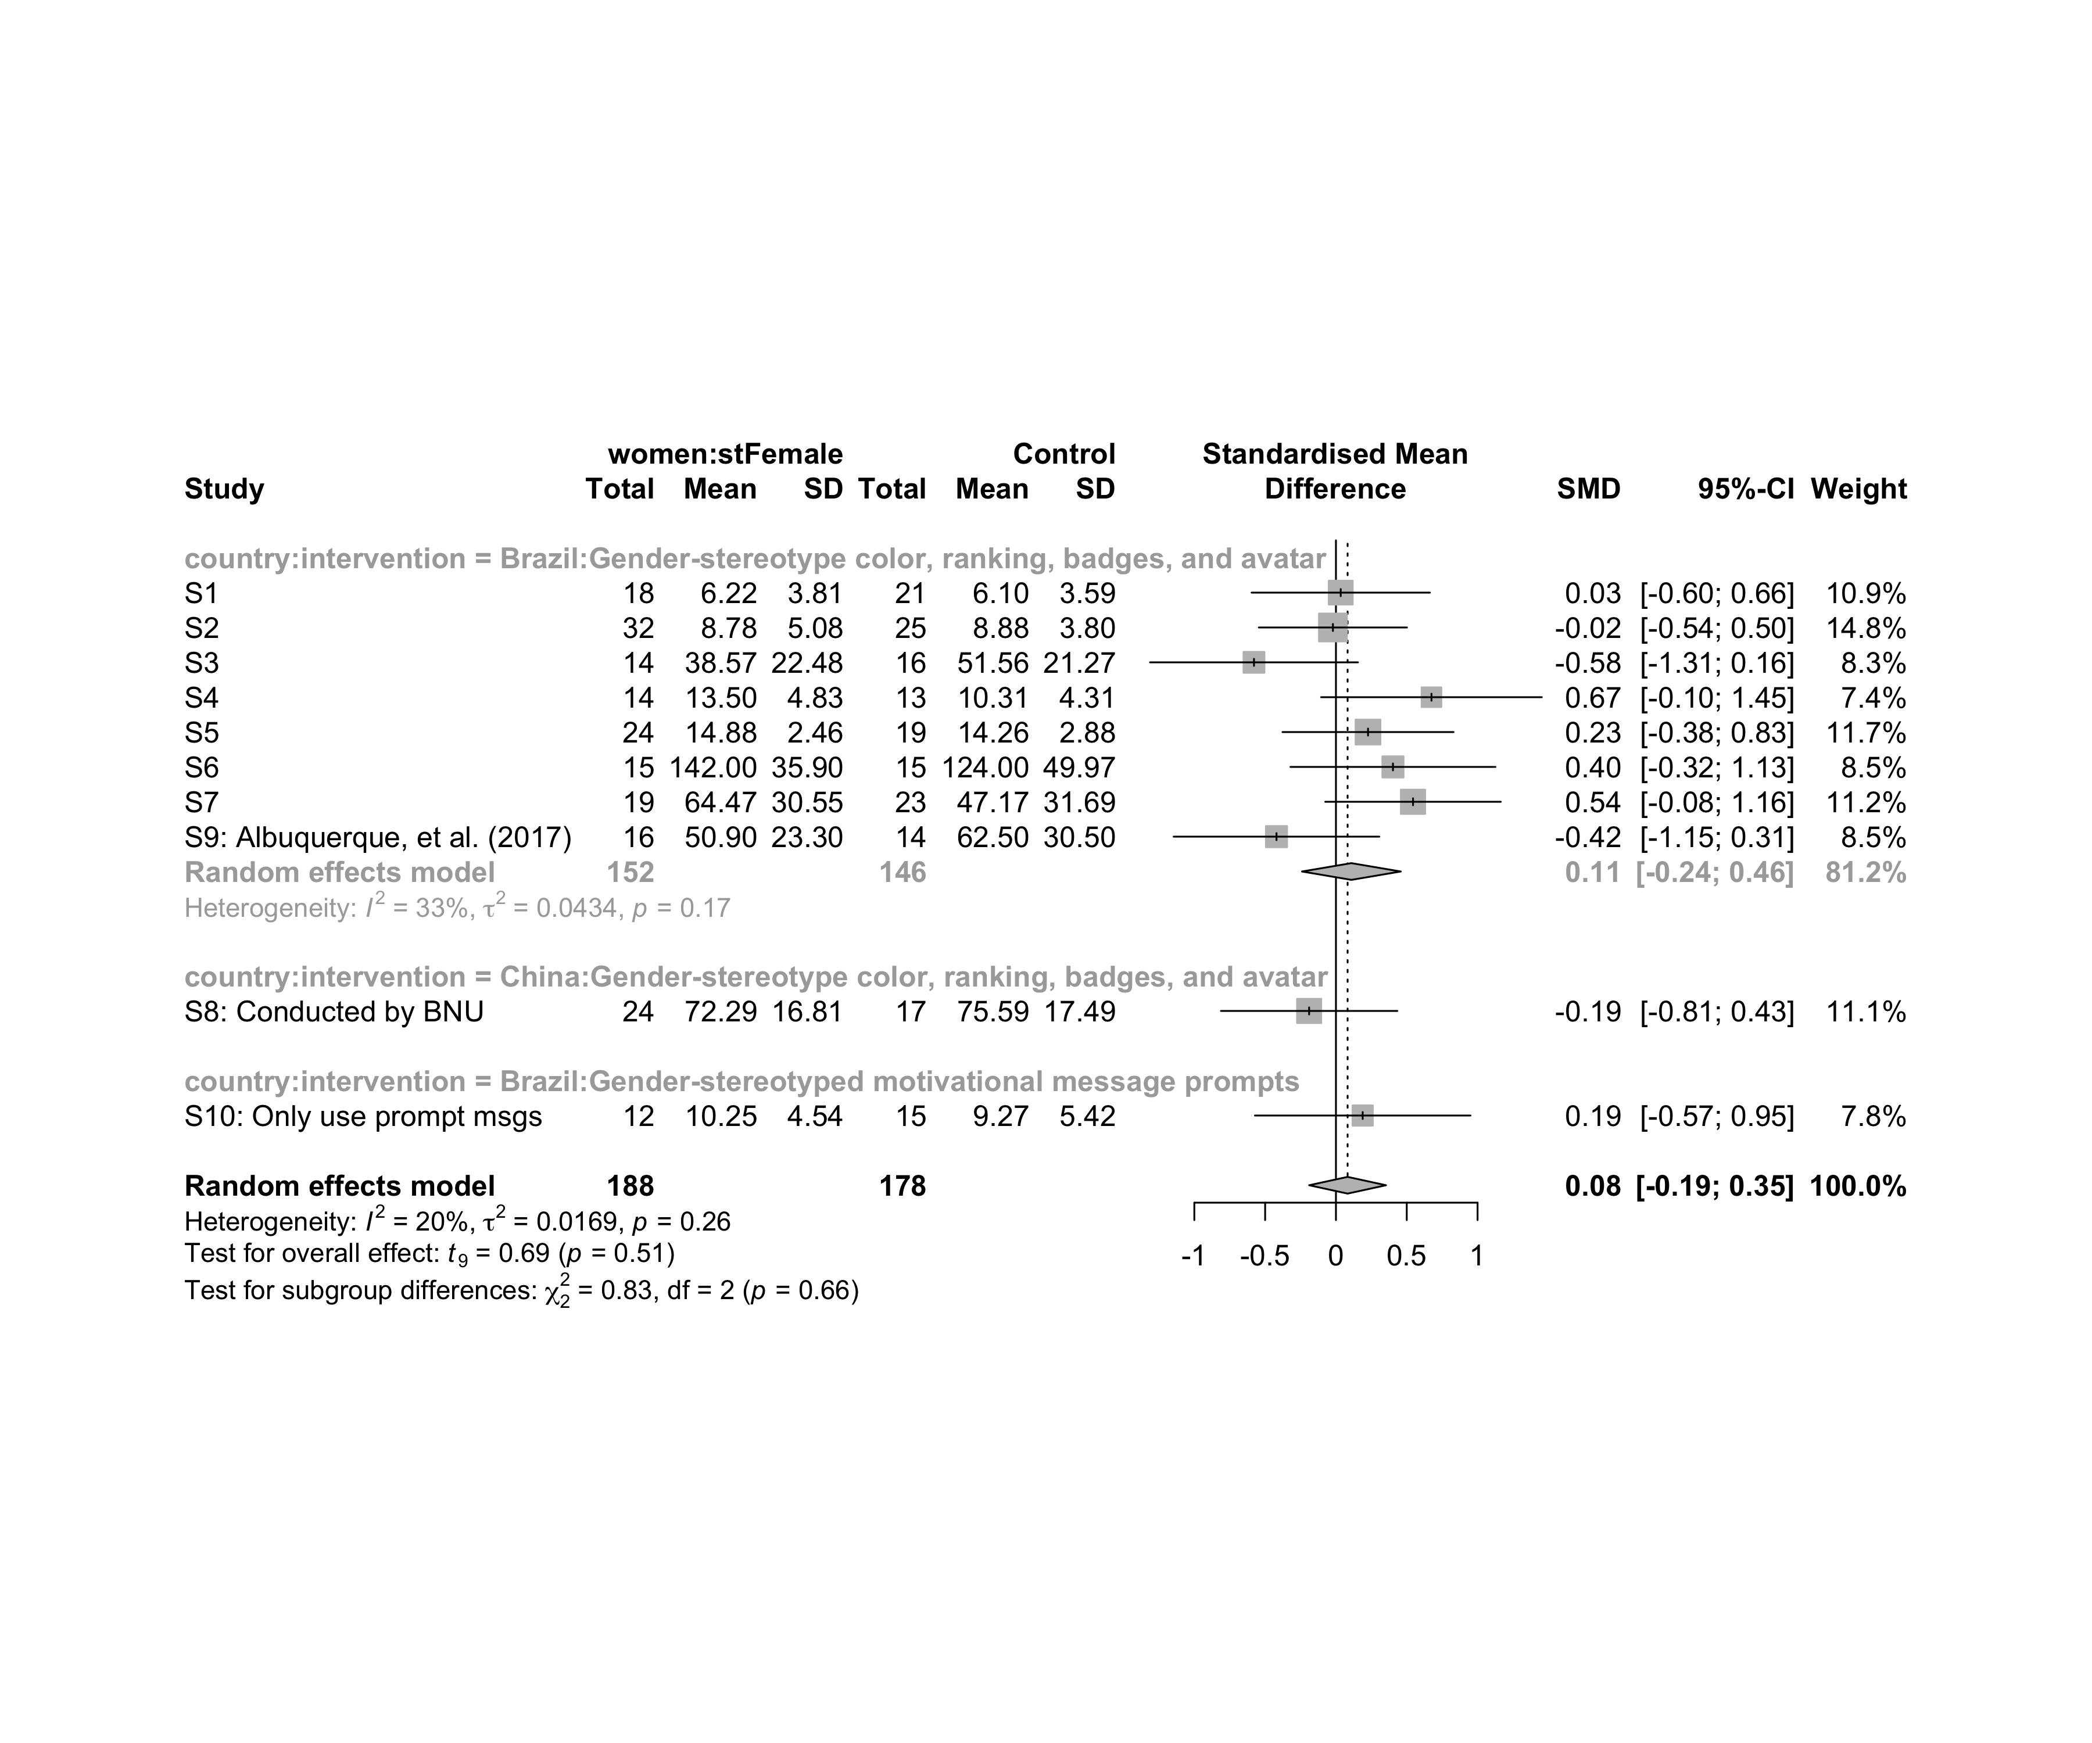

### Subgroup analysis by “age:intervention”

m.sg4sub <- update.meta(m.cont, subgroup = `age:intervention`, random = T, fixed = F)  
summary(m.sg4sub)

## Review: Performance for women in stFemale  
##   
## SMD 95%-CI %W(random)  
## S1 0.0337 [-0.5959; 0.6633] 10.9  
## S2 -0.0214 [-0.5446; 0.5018] 14.8  
## S3 -0.5787 [-1.3128; 0.1555] 8.3  
## S4 0.6745 [-0.1048; 1.4539] 7.4  
## S5 0.2265 [-0.3774; 0.8305] 11.7  
## S6 0.4025 [-0.3214; 1.1264] 8.5  
## S7 0.5444 [-0.0754; 1.1641] 11.2  
## S8: Conducted by BNU -0.1893 [-0.8121; 0.4335] 11.1  
## S9: Albuquerque, et al. (2017) -0.4198 [-1.1460; 0.3064] 8.5  
## S10: Only use prompt msgs 0.1888 [-0.5722; 0.9498] 7.8  
## age:intervention  
## S1 adolescent:Gender-stereotype color, ranking, badges, and avatar  
## S2 adolescent:Gender-stereotype color, ranking, badges, and avatar  
## S3 adolescent:Gender-stereotype color, ranking, badges, and avatar  
## S4 adult:Gender-stereotype color, ranking, badges, and avatar  
## S5 adult:Gender-stereotype color, ranking, badges, and avatar  
## S6 adult:Gender-stereotype color, ranking, badges, and avatar  
## S7 adult:Gender-stereotype color, ranking, badges, and avatar  
## S8: Conducted by BNU unknown:Gender-stereotype color, ranking, badges, and avatar  
## S9: Albuquerque, et al. (2017) no-restriction:Gender-stereotype color, ranking, badges, and avatar  
## S10: Only use prompt msgs adolescent:Gender-stereotyped motivational message prompts  
##   
## Number of studies combined: k = 10  
## Number of observations: o = 366  
##   
## SMD 95%-CI t p-value  
## Random effects model 0.0823 [-0.1890; 0.3537] 0.69 0.5098  
##   
## Quantifying heterogeneity:  
## tau^2 = 0.0169 [0.0000; 0.4121]; tau = 0.1299 [0.0000; 0.6420]  
## I^2 = 20.0% [0.0%; 60.5%]; H = 1.12 [1.00; 1.59]  
##   
## Test of heterogeneity:  
## Q d.f. p-value  
## 11.25 9 0.2587  
##   
## Results for subgroups (random effects model):  
## k SMD 95%-CI tau^2 tau Q  
## age:intervention = adolescent:Gender-stereotype co ... 3 -0.1328 [-0.8798; 0.6141] <0.0001 0.0007 1.86  
## age:intervention = adult:Gender-stereotype color, ... 4 0.4401 [ 0.1343; 0.7459] 0 0 0.95  
## age:intervention = unknown:Gender-stereotype color ... 1 -0.1893 [-0.8121; 0.4335] -- -- 0.00  
## age:intervention = no-restriction:Gender-stereotyp ... 1 -0.4198 [-1.1460; 0.3064] -- -- 0.00  
## age:intervention = adolescent:Gender-stereotyped m ... 1 0.1888 [-0.5722; 0.9498] -- -- 0.00  
## I^2  
## age:intervention = adolescent:Gender-stereotype co ... 0.0%  
## age:intervention = adult:Gender-stereotype color, ... 0.0%  
## age:intervention = unknown:Gender-stereotype color ... --  
## age:intervention = no-restriction:Gender-stereotyp ... --  
## age:intervention = adolescent:Gender-stereotyped m ... --  
##   
## Test for subgroup differences (random effects model):  
## Q d.f. p-value  
## Between groups 13.96 4 0.0074  
##   
## Details on meta-analytical method:  
## - Inverse variance method  
## - Restricted maximum-likelihood estimator for tau^2  
## - Q-profile method for confidence interval of tau^2 and tau  
## - Hartung-Knapp adjustment for random effects model  
## - Hedges' g (bias corrected standardised mean difference; using exact formulae)

forest(m.sg4sub, digits=2, digits.sd = 2, test.overall = T, label.e = paste0(gender,':',env))

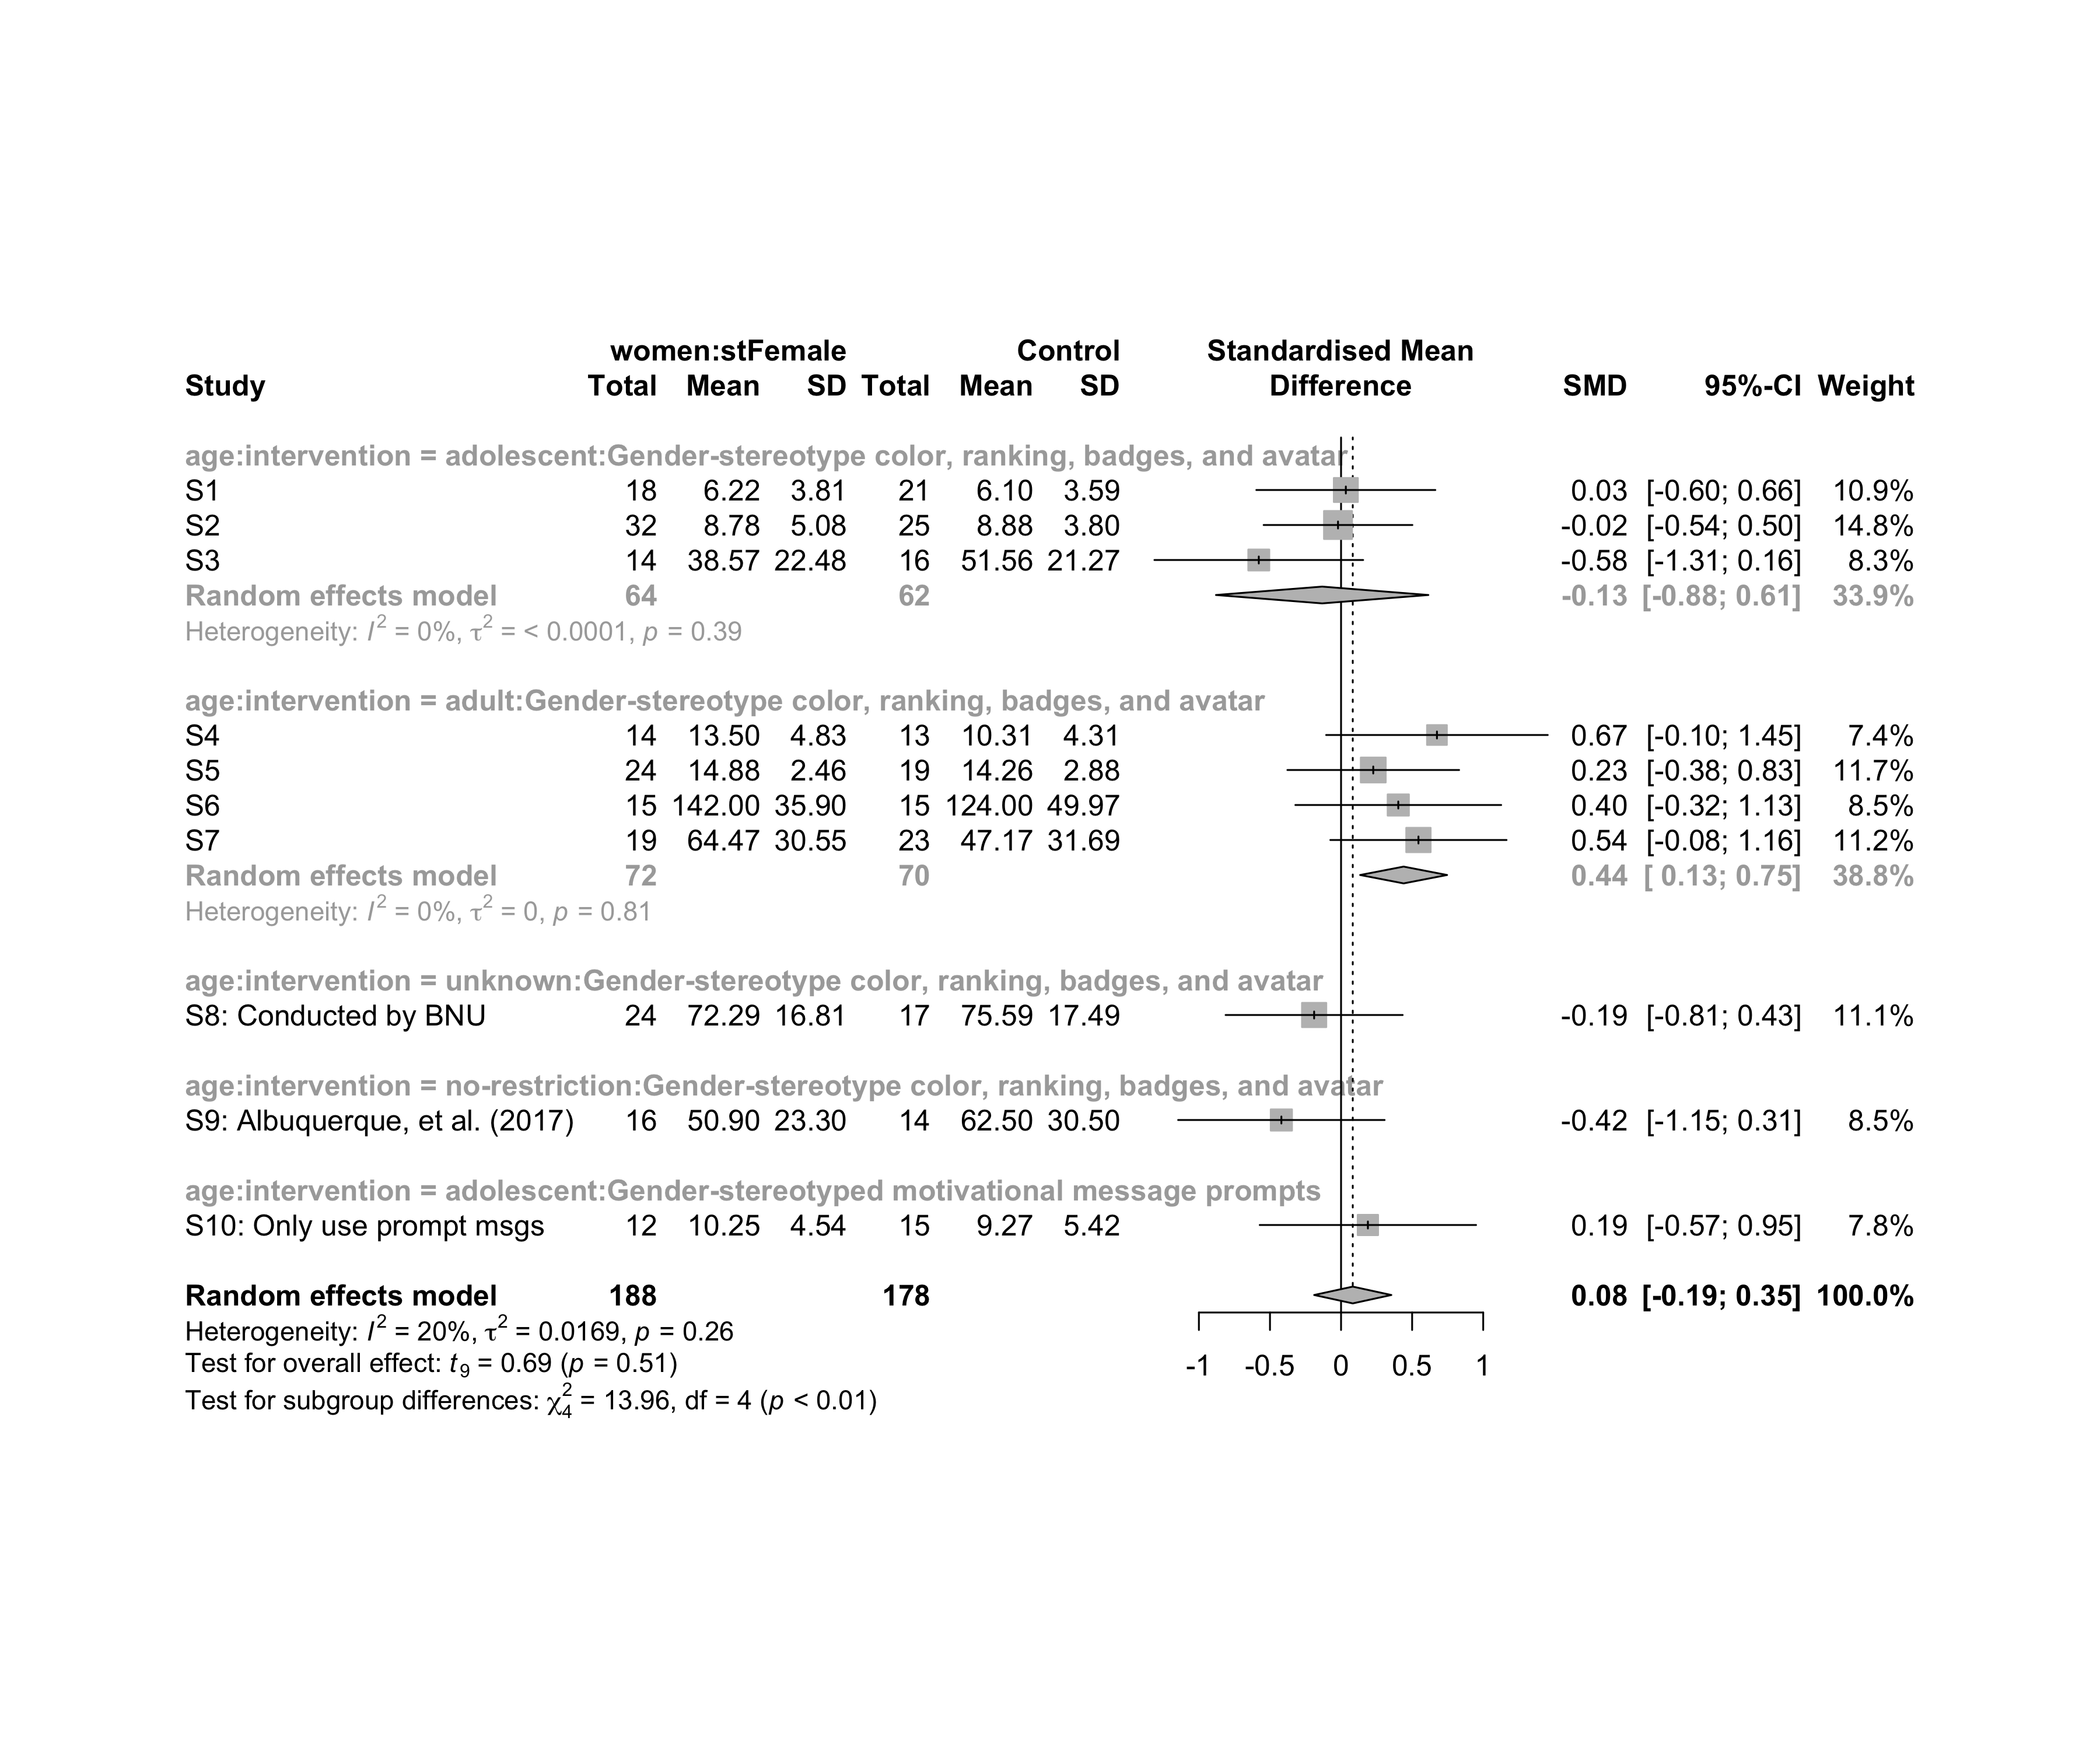

### Subgroup analysis by “ed.level:intervention”

m.sg4sub <- update.meta(m.cont, subgroup = `ed.level:intervention`, random = T, fixed = F)  
summary(m.sg4sub)

## Review: Performance for women in stFemale  
##   
## SMD 95%-CI %W(random)  
## S1 0.0337 [-0.5959; 0.6633] 10.9  
## S2 -0.0214 [-0.5446; 0.5018] 14.8  
## S3 -0.5787 [-1.3128; 0.1555] 8.3  
## S4 0.6745 [-0.1048; 1.4539] 7.4  
## S5 0.2265 [-0.3774; 0.8305] 11.7  
## S6 0.4025 [-0.3214; 1.1264] 8.5  
## S7 0.5444 [-0.0754; 1.1641] 11.2  
## S8: Conducted by BNU -0.1893 [-0.8121; 0.4335] 11.1  
## S9: Albuquerque, et al. (2017) -0.4198 [-1.1460; 0.3064] 8.5  
## S10: Only use prompt msgs 0.1888 [-0.5722; 0.9498] 7.8  
## ed.level:intervention  
## S1 upper-secundary:Gender-stereotype color, ranking, badges, and avatar  
## S2 upper-secundary:Gender-stereotype color, ranking, badges, and avatar  
## S3 upper-secundary:Gender-stereotype color, ranking, badges, and avatar  
## S4 higher-education:Gender-stereotype color, ranking, badges, and avatar  
## S5 higher-education:Gender-stereotype color, ranking, badges, and avatar  
## S6 higher-education:Gender-stereotype color, ranking, badges, and avatar  
## S7 unknown:Gender-stereotype color, ranking, badges, and avatar  
## S8: Conducted by BNU unknown:Gender-stereotype color, ranking, badges, and avatar  
## S9: Albuquerque, et al. (2017) unknown:Gender-stereotype color, ranking, badges, and avatar  
## S10: Only use prompt msgs upper-secundary:Gender-stereotyped motivational message prompts  
##   
## Number of studies combined: k = 10  
## Number of observations: o = 366  
##   
## SMD 95%-CI t p-value  
## Random effects model 0.0823 [-0.1890; 0.3537] 0.69 0.5098  
##   
## Quantifying heterogeneity:  
## tau^2 = 0.0169 [0.0000; 0.4121]; tau = 0.1299 [0.0000; 0.6420]  
## I^2 = 20.0% [0.0%; 60.5%]; H = 1.12 [1.00; 1.59]  
##   
## Test of heterogeneity:  
## Q d.f. p-value  
## 11.25 9 0.2587  
##   
## Results for subgroups (random effects model):  
## k SMD 95%-CI tau^2 tau  
## ed.level:intervention = upper-secundary:Gender-stereoty ... 3 -0.1328 [-0.8798; 0.6141] <0.0001 0.0007  
## ed.level:intervention = higher-education:Gender-stereot ... 3 0.3970 [-0.1540; 0.9481] 0 0  
## ed.level:intervention = unknown:Gender-stereotype color ... 3 -0.0029 [-1.2549; 1.2491] 0.1440 0.3795  
## ed.level:intervention = upper-secundary:Gender-stereoty ... 1 0.1888 [-0.5722; 0.9498] -- --  
## Q I^2  
## ed.level:intervention = upper-secundary:Gender-stereoty ... 1.86 0.0%  
## ed.level:intervention = higher-education:Gender-stereot ... 0.79 0.0%  
## ed.level:intervention = unknown:Gender-stereotype color ... 4.59 56.5%  
## ed.level:intervention = upper-secundary:Gender-stereoty ... 0.00 --  
##   
## Test for subgroup differences (random effects model):  
## Q d.f. p-value  
## Between groups 6.51 3 0.0893  
##   
## Details on meta-analytical method:  
## - Inverse variance method  
## - Restricted maximum-likelihood estimator for tau^2  
## - Q-profile method for confidence interval of tau^2 and tau  
## - Hartung-Knapp adjustment for random effects model  
## - Hedges' g (bias corrected standardised mean difference; using exact formulae)

forest(m.sg4sub, digits=2, digits.sd = 2, test.overall = T, label.e = paste0(gender,':',env))

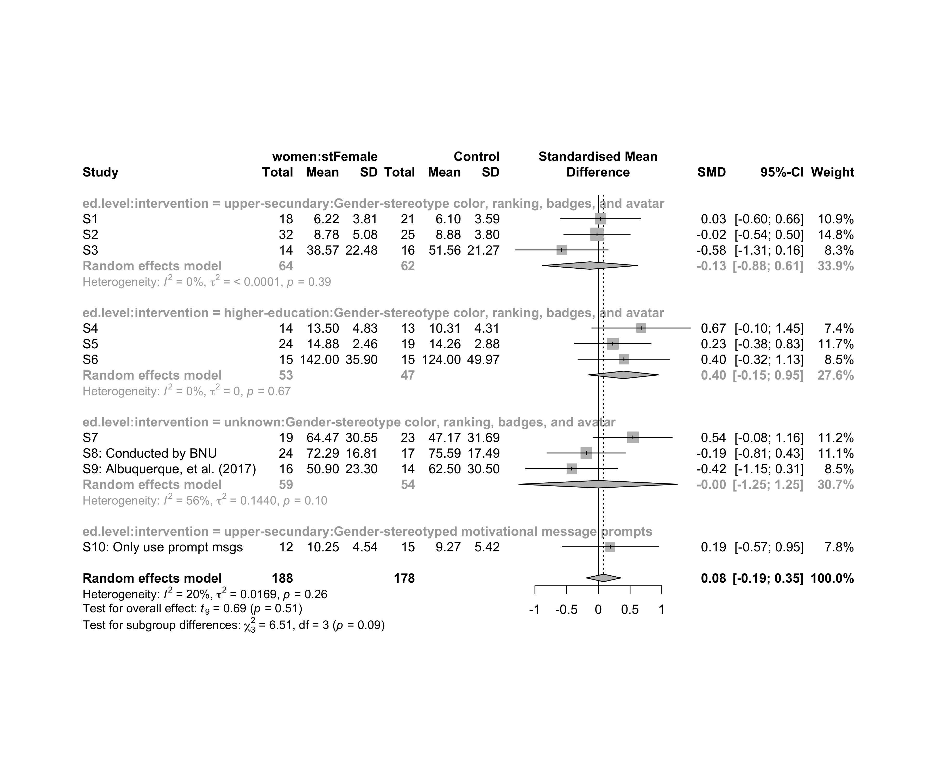

### Subgroup analysis by “country:age:intervention”

m.sg4sub <- update.meta(m.cont, subgroup = `country:age:intervention`, random = T, fixed = F)  
summary(m.sg4sub)

## Review: Performance for women in stFemale  
##   
## SMD 95%-CI %W(random)  
## S1 0.0337 [-0.5959; 0.6633] 10.9  
## S2 -0.0214 [-0.5446; 0.5018] 14.8  
## S3 -0.5787 [-1.3128; 0.1555] 8.3  
## S4 0.6745 [-0.1048; 1.4539] 7.4  
## S5 0.2265 [-0.3774; 0.8305] 11.7  
## S6 0.4025 [-0.3214; 1.1264] 8.5  
## S7 0.5444 [-0.0754; 1.1641] 11.2  
## S8: Conducted by BNU -0.1893 [-0.8121; 0.4335] 11.1  
## S9: Albuquerque, et al. (2017) -0.4198 [-1.1460; 0.3064] 8.5  
## S10: Only use prompt msgs 0.1888 [-0.5722; 0.9498] 7.8  
## country:age:intervention  
## S1 Brazil:adolescent:Gender-stereotype color, ranking, badges, and avatar  
## S2 Brazil:adolescent:Gender-stereotype color, ranking, badges, and avatar  
## S3 Brazil:adolescent:Gender-stereotype color, ranking, badges, and avatar  
## S4 Brazil:adult:Gender-stereotype color, ranking, badges, and avatar  
## S5 Brazil:adult:Gender-stereotype color, ranking, badges, and avatar  
## S6 Brazil:adult:Gender-stereotype color, ranking, badges, and avatar  
## S7 Brazil:adult:Gender-stereotype color, ranking, badges, and avatar  
## S8: Conducted by BNU China:unknown:Gender-stereotype color, ranking, badges, and avatar  
## S9: Albuquerque, et al. (2017) Brazil:no-restriction:Gender-stereotype color, ranking, badges, and avatar  
## S10: Only use prompt msgs Brazil:adolescent:Gender-stereotyped motivational message prompts  
##   
## Number of studies combined: k = 10  
## Number of observations: o = 366  
##   
## SMD 95%-CI t p-value  
## Random effects model 0.0823 [-0.1890; 0.3537] 0.69 0.5098  
##   
## Quantifying heterogeneity:  
## tau^2 = 0.0169 [0.0000; 0.4121]; tau = 0.1299 [0.0000; 0.6420]  
## I^2 = 20.0% [0.0%; 60.5%]; H = 1.12 [1.00; 1.59]  
##   
## Test of heterogeneity:  
## Q d.f. p-value  
## 11.25 9 0.2587  
##   
## Results for subgroups (random effects model):  
## k SMD 95%-CI tau^2 tau  
## country:age:intervention = Brazil:adolescent:Gender-stereo ... 3 -0.1328 [-0.8798; 0.6141] <0.0001 0.0007  
## country:age:intervention = Brazil:adult:Gender-stereotype ... 4 0.4401 [ 0.1343; 0.7459] 0 0  
## country:age:intervention = China:unknown:Gender-stereotype ... 1 -0.1893 [-0.8121; 0.4335] -- --  
## country:age:intervention = Brazil:no-restriction:Gender-st ... 1 -0.4198 [-1.1460; 0.3064] -- --  
## country:age:intervention = Brazil:adolescent:Gender-stereo ... 1 0.1888 [-0.5722; 0.9498] -- --  
## Q I^2  
## country:age:intervention = Brazil:adolescent:Gender-stereo ... 1.86 0.0%  
## country:age:intervention = Brazil:adult:Gender-stereotype ... 0.95 0.0%  
## country:age:intervention = China:unknown:Gender-stereotype ... 0.00 --  
## country:age:intervention = Brazil:no-restriction:Gender-st ... 0.00 --  
## country:age:intervention = Brazil:adolescent:Gender-stereo ... 0.00 --  
##   
## Test for subgroup differences (random effects model):  
## Q d.f. p-value  
## Between groups 13.96 4 0.0074  
##   
## Details on meta-analytical method:  
## - Inverse variance method  
## - Restricted maximum-likelihood estimator for tau^2  
## - Q-profile method for confidence interval of tau^2 and tau  
## - Hartung-Knapp adjustment for random effects model  
## - Hedges' g (bias corrected standardised mean difference; using exact formulae)

forest(m.sg4sub, digits=2, digits.sd = 2, test.overall = T, label.e = paste0(gender,':',env))

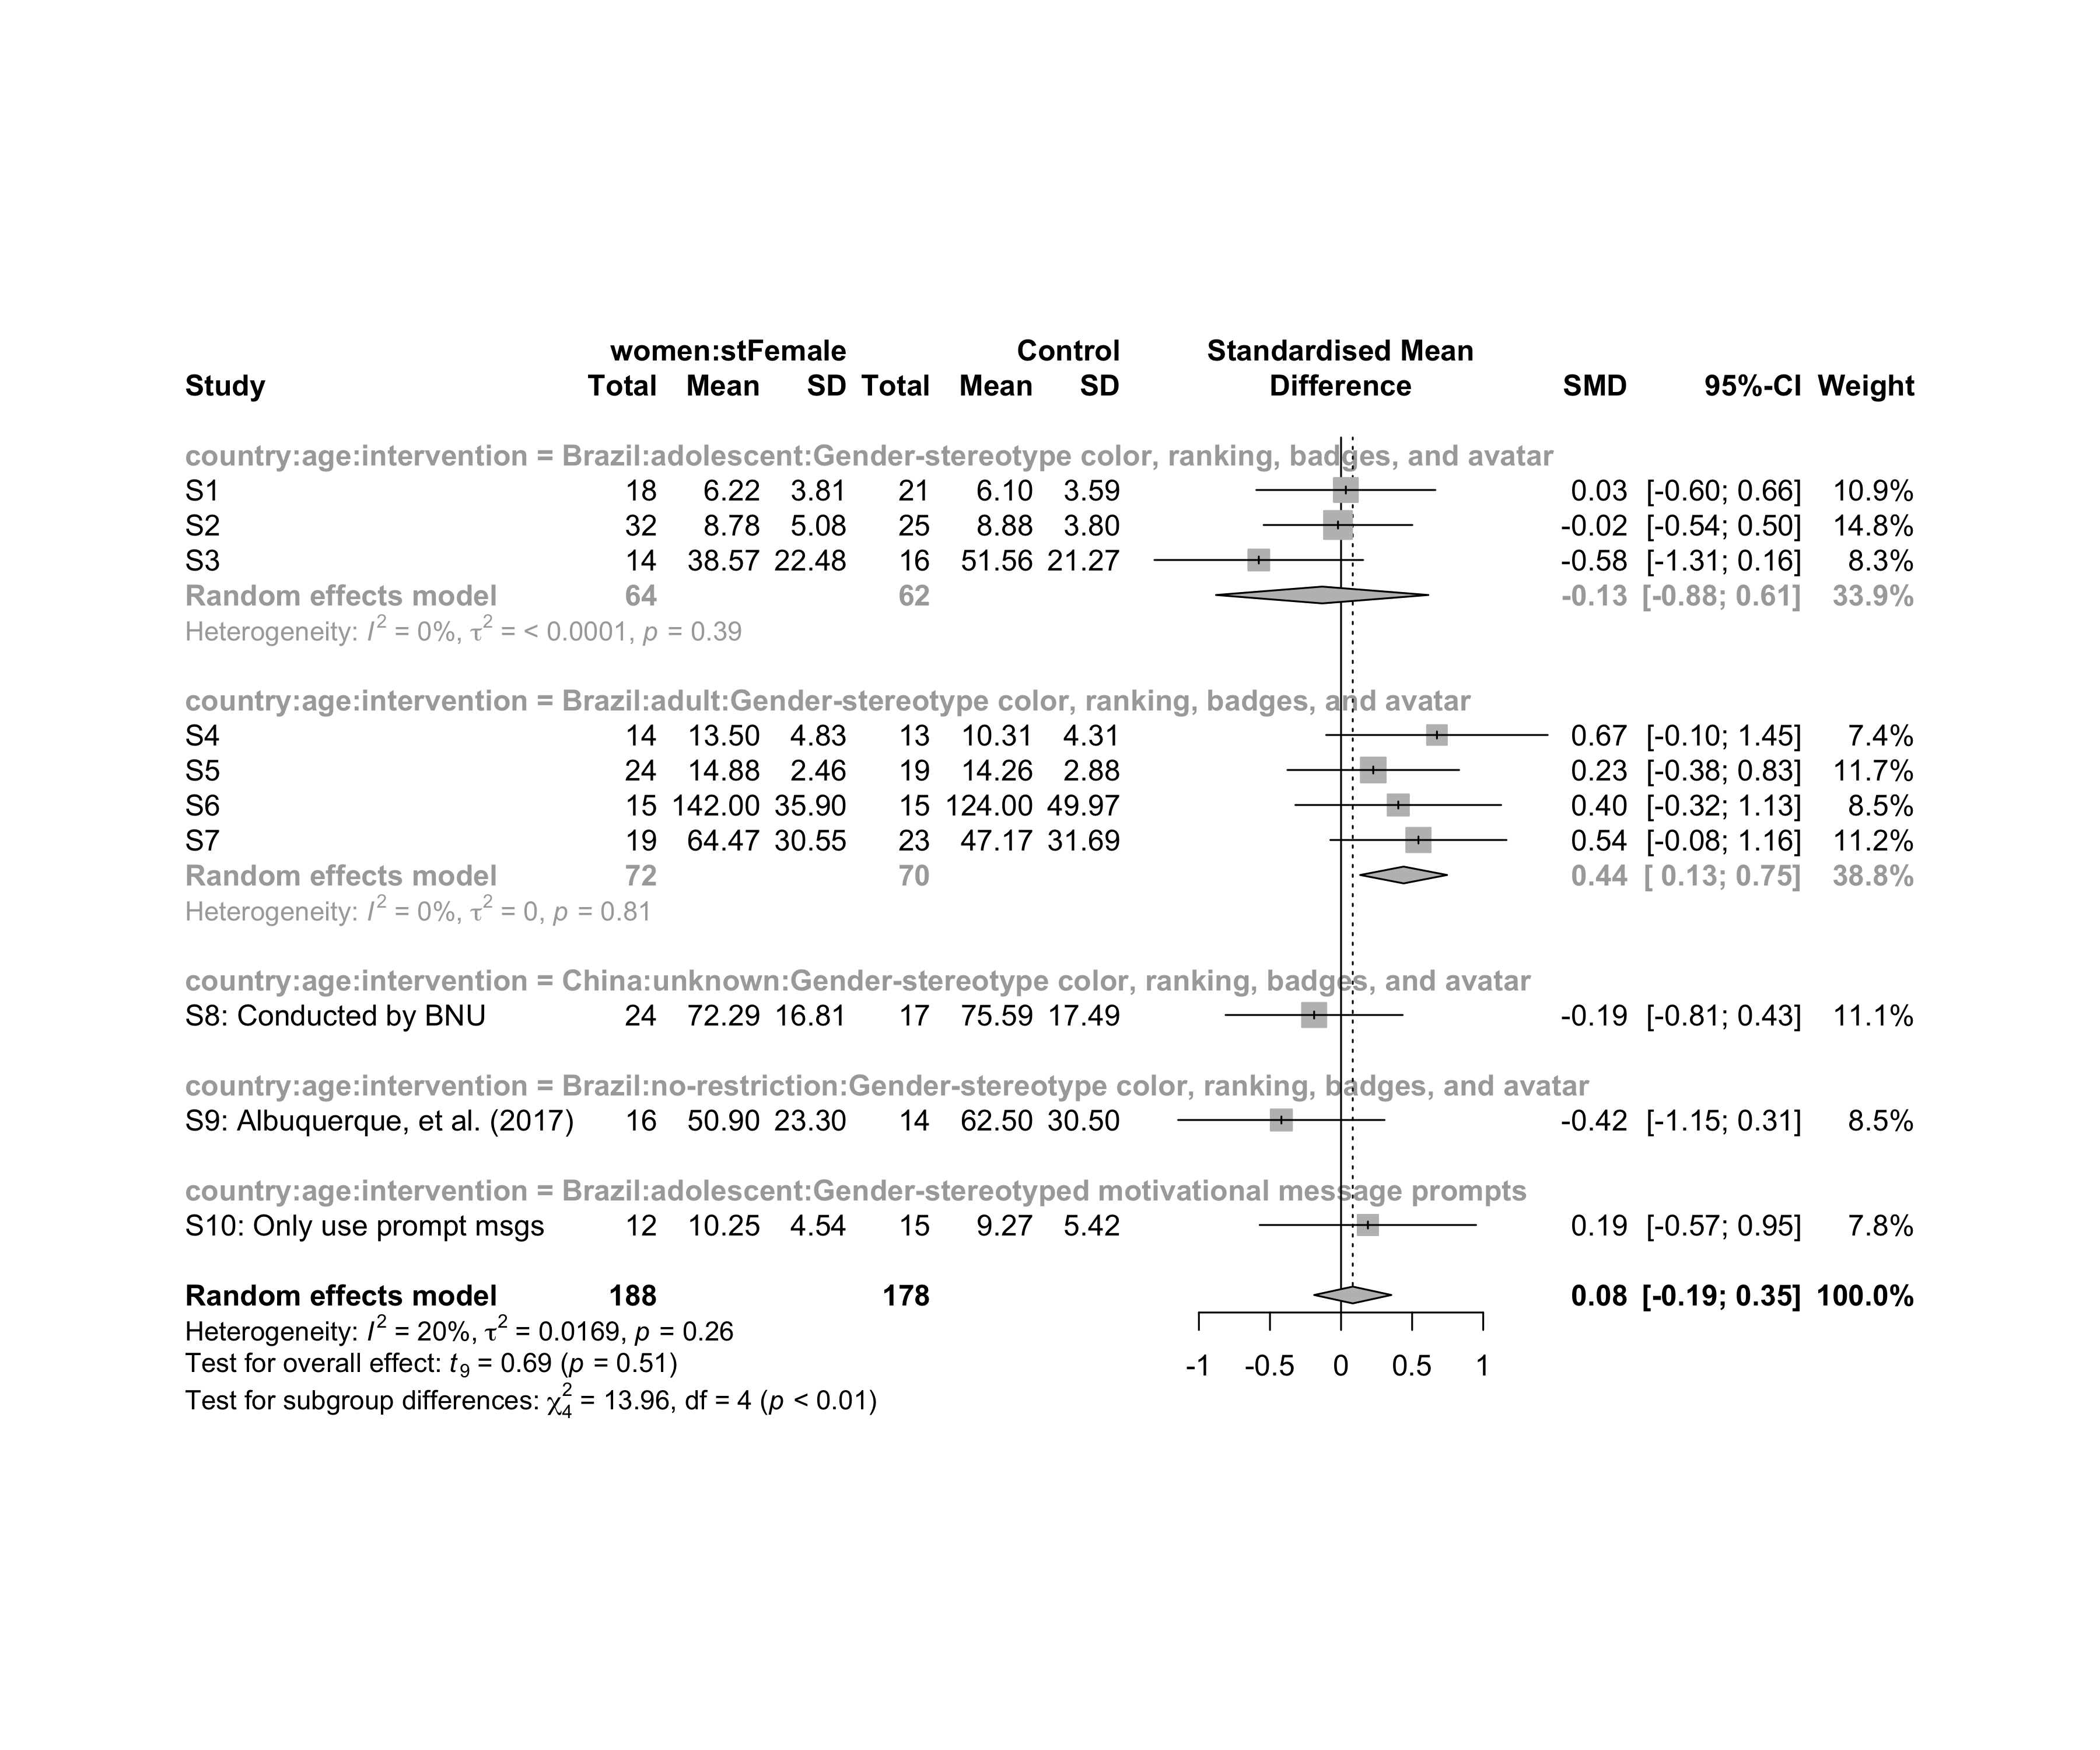

### Subgroup analysis by “country:ed.level:intervention”

m.sg4sub <- update.meta(m.cont, subgroup = `country:ed.level:intervention`, random = T, fixed = F)  
summary(m.sg4sub)

## Review: Performance for women in stFemale  
##   
## SMD 95%-CI %W(random)  
## S1 0.0337 [-0.5959; 0.6633] 10.9  
## S2 -0.0214 [-0.5446; 0.5018] 14.8  
## S3 -0.5787 [-1.3128; 0.1555] 8.3  
## S4 0.6745 [-0.1048; 1.4539] 7.4  
## S5 0.2265 [-0.3774; 0.8305] 11.7  
## S6 0.4025 [-0.3214; 1.1264] 8.5  
## S7 0.5444 [-0.0754; 1.1641] 11.2  
## S8: Conducted by BNU -0.1893 [-0.8121; 0.4335] 11.1  
## S9: Albuquerque, et al. (2017) -0.4198 [-1.1460; 0.3064] 8.5  
## S10: Only use prompt msgs 0.1888 [-0.5722; 0.9498] 7.8  
## country:ed.level:intervention  
## S1 Brazil:upper-secundary:Gender-stereotype color, ranking, badges, and avatar  
## S2 Brazil:upper-secundary:Gender-stereotype color, ranking, badges, and avatar  
## S3 Brazil:upper-secundary:Gender-stereotype color, ranking, badges, and avatar  
## S4 Brazil:higher-education:Gender-stereotype color, ranking, badges, and avatar  
## S5 Brazil:higher-education:Gender-stereotype color, ranking, badges, and avatar  
## S6 Brazil:higher-education:Gender-stereotype color, ranking, badges, and avatar  
## S7 Brazil:unknown:Gender-stereotype color, ranking, badges, and avatar  
## S8: Conducted by BNU China:unknown:Gender-stereotype color, ranking, badges, and avatar  
## S9: Albuquerque, et al. (2017) Brazil:unknown:Gender-stereotype color, ranking, badges, and avatar  
## S10: Only use prompt msgs Brazil:upper-secundary:Gender-stereotyped motivational message prompts  
##   
## Number of studies combined: k = 10  
## Number of observations: o = 366  
##   
## SMD 95%-CI t p-value  
## Random effects model 0.0823 [-0.1890; 0.3537] 0.69 0.5098  
##   
## Quantifying heterogeneity:  
## tau^2 = 0.0169 [0.0000; 0.4121]; tau = 0.1299 [0.0000; 0.6420]  
## I^2 = 20.0% [0.0%; 60.5%]; H = 1.12 [1.00; 1.59]  
##   
## Test of heterogeneity:  
## Q d.f. p-value  
## 11.25 9 0.2587  
##   
## Results for subgroups (random effects model):  
## k SMD 95%-CI tau^2  
## country:ed.level:intervention = Brazil:upper-secundary:Gender-s ... 3 -0.1328 [-0.8798; 0.6141] <0.0001  
## country:ed.level:intervention = Brazil:higher-education:Gender- ... 3 0.3970 [-0.1540; 0.9481] 0  
## country:ed.level:intervention = Brazil:unknown:Gender-stereotyp ... 2 0.0816 [-6.0390; 6.2023] 0.3462  
## country:ed.level:intervention = China:unknown:Gender-stereotype ... 1 -0.1893 [-0.8121; 0.4335] --  
## country:ed.level:intervention = Brazil:upper-secundary:Gender-s ... 1 0.1888 [-0.5722; 0.9498] --  
## tau Q I^2  
## country:ed.level:intervention = Brazil:upper-secundary:Gender-s ... 0.0007 1.86 0.0%  
## country:ed.level:intervention = Brazil:higher-education:Gender- ... 0 0.79 0.0%  
## country:ed.level:intervention = Brazil:unknown:Gender-stereotyp ... 0.5884 3.92 74.5%  
## country:ed.level:intervention = China:unknown:Gender-stereotype ... -- 0.00 --  
## country:ed.level:intervention = Brazil:upper-secundary:Gender-s ... -- 0.00 --  
##   
## Test for subgroup differences (random effects model):  
## Q d.f. p-value  
## Between groups 7.50 4 0.1117  
##   
## Details on meta-analytical method:  
## - Inverse variance method  
## - Restricted maximum-likelihood estimator for tau^2  
## - Q-profile method for confidence interval of tau^2 and tau  
## - Hartung-Knapp adjustment for random effects model  
## - Hedges' g (bias corrected standardised mean difference; using exact formulae)

forest(m.sg4sub, digits=2, digits.sd = 2, test.overall = T, label.e = paste0(gender,':',env))

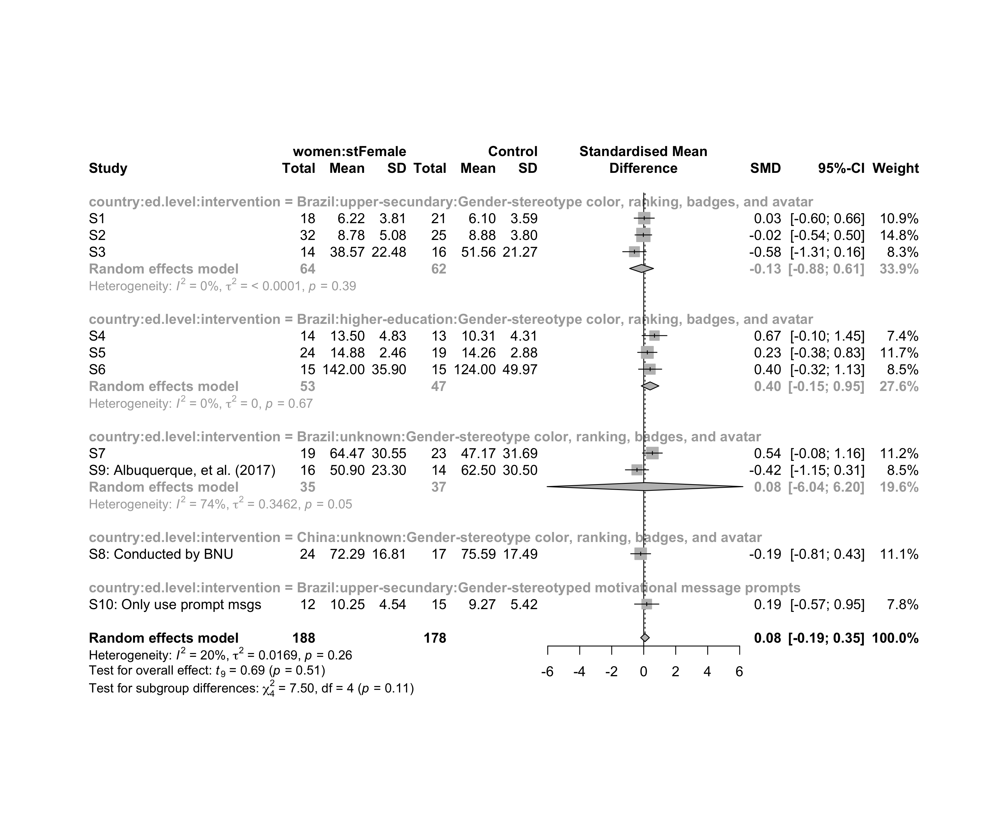

## Funnel Plot

m.cont <- update.meta(m.cont, studlab = data$study)  
summary(eggers.test(x = m.cont))

## Eggers' test of the intercept   
## =============================   
##   
## intercept 95% CI t p  
## 0.397 -5.54 - 6.33 0.131 0.9  
##   
## Eggers' test does not indicate the presence of funnel plot asymmetry.

funnel(m.cont, xlab = "Hedges' g", studlab = T, legend=T, addtau2 = T)

